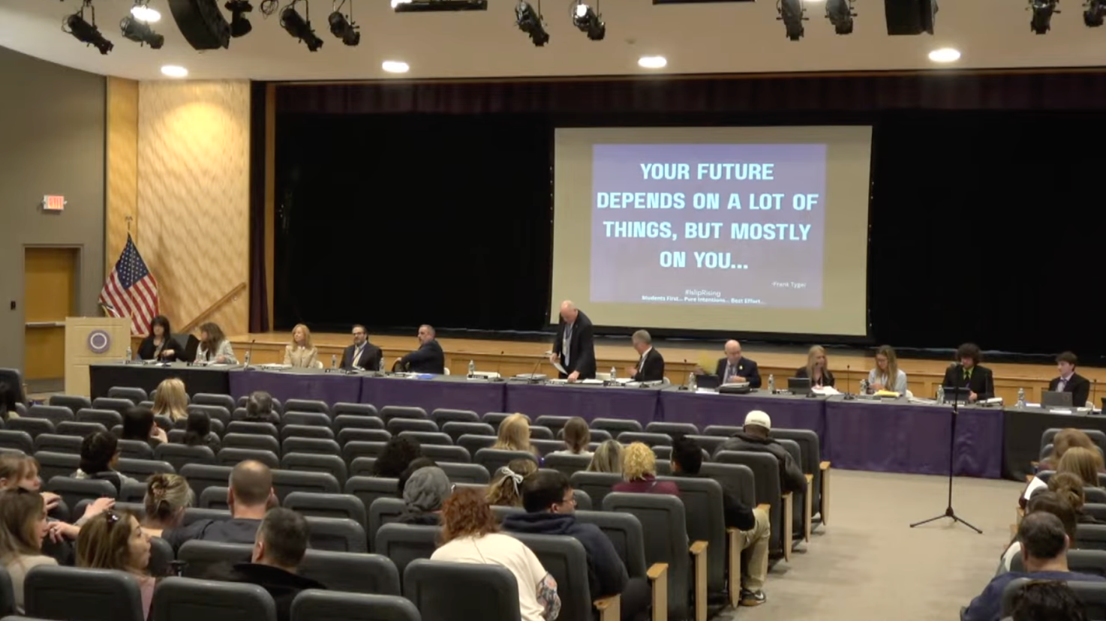

Islip Board of Education Meeting
Tuesday, March 10, 2026
edited transcript of video recording, available on Islip BOE YouTube channel

Everyone's attention please…. I'd like to welcome everyone here tonight's board meeting. …We have a lot of exciting things that we're going to be talking about this evening. We're going to start off right now with our Suffolk community partnership and we’ll have our board go sit up front and we'll turn it over to our student board member who'll actually start the presentation for us this evening.

STUDENT BOARD MEMBER >> All right. Thank you everyone for coming out tonight. Um, thanks to the board of education for being here, high school administration, parents, students, everyone. Means a lot for the auditorium to get this packed, we rarely see it. So that's, that's really nice. But, um, I'd like to talk about an amazing opportunity tonight for high school age students at Islip High School to get an associate’s degree as they graduate high school.

“Your future depends on a lot of things, but mostly on you.” We'll talk more about what that means.

- College partnership, pathways to a high school diploma, and associate’s degree. Um, we have Edward T. Bonahue and Dr. Dennis O'Hara that's going to help me out with this presentation that was so thoughtfully prepared.

Next, I'd just like to talk about the, uh, agenda for tonight. What we're going to go over first, um

- The welcoming introduction of special guests
- We're going to talk about why education pays, literally
- What we know and why we are here
- High aspirations versus high costs and other barriers
- A gem in our own backyard where ambition meets opportunity
- How high school hustle will equal college muscle
- And then, at the end, we'll have time for some question and answers.

And with that, I'd just like to introduce some people. Um, I'd like to introduce

- Dr. Edward Bonahue, the President of Suffolk County Community College
- Dr. Irene Rios, Vice President of Academic Affairs and Ammerman Campus CEO
- Lisa Calla, Assistant Dean for K through 12 programs from Suffolk County Community College
- Mr. John Dolan, Board of Trustees for Suffolk County Community College
- Mr. Samuel Gonzalez, Suffolk County Legislator for District 9
- Mr. Steven Flotteron, Suffolk County Legislator for District 11
- Miss Trish Bergin, Suffolk County Legislator, also the education committee chair. Unfortunately, she couldn't make it out tonight, but she said she really wishes she could have been here
- Miss Katherine Romano, Eastern Suffolk BOCES Board of Ed
- Mr. Robert Vecchio, Executive Director of Nassau-Suffolk School Boards Association.

And with that, I'd like to introduce Dr. Dennis O'Hara, who's going to take it from here.

ISLIP SUPERINTENDENT DENNIS O’HARA >> Thank you, Brody. Thank you everyone for being here this evening. Um, Brody's just one example of the many fine young people we have in our schools. You guys know that there's about 2,700 [unclear?] more students like Brody.

So, um, but we started with this slide when you walked in. I was hoping that message would percolate for people. And for any students in the room, I want you to know that your future does depend on a lot of things, but mostly it depends on how hard you work and how much effort you put in and, and, uh, how much focus you have on your personal goals. So that'll be the theme throughout this presentation this evening because we're proposing something that's an extraordinary opportunity and we're also proposing something that will take an incredible amount of work to accomplish. We think it's possible for some of our students—and we think there's another piece of this is possible for many more of our students.

So Brody took us through an agenda and I'm going to take you through some of those steps now.

So what do we know about postsecondary education and why does it matter? We're in an era where tuition and fees are growing and growing and growing at a pace that's much faster than income is growing and it's outpacing families’ ability to afford a college education. And because of that, some people think that there are healthier alternatives or maybe a faster alternative. While that may be true, I'd like just to take a look at some of these data for a moment.

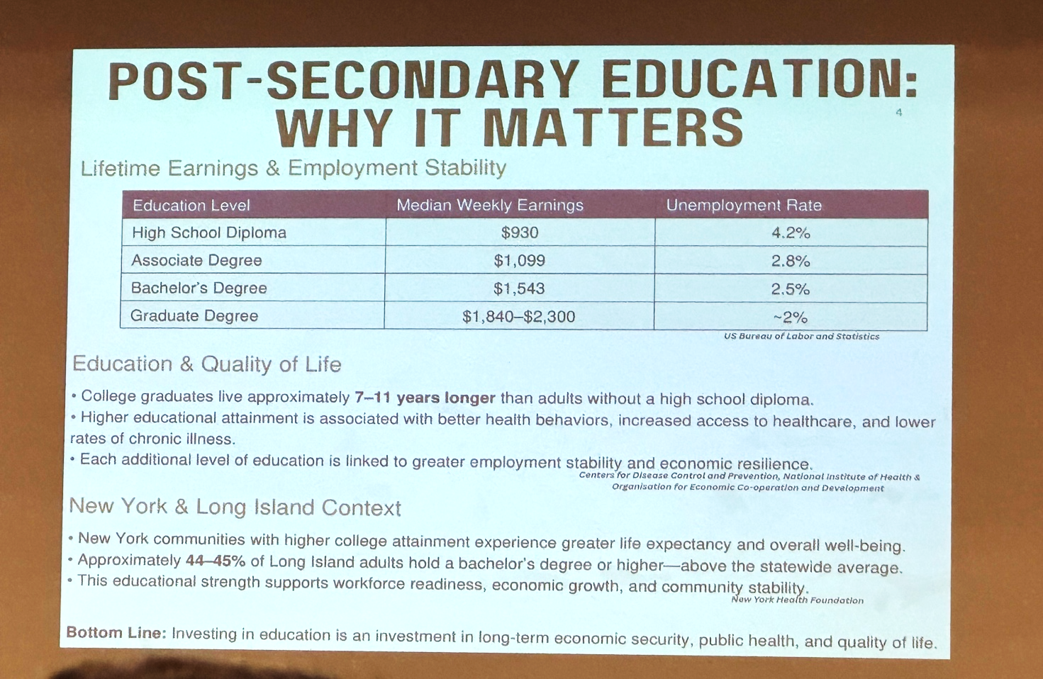

As you can see, this chart shows what happens to your earnings potential as you advance your education beyond high school. You can also see what happens to your chances or possibility of finding yourself unemployed. So, in one case, it's a direct relationship. The further your education goes, the higher your income goes. In the other case, it's an inverse relationship. The, uh, less education, the more likely you may be to find yourself unemployed.
- College graduates live approximately 7 to 11 years longer than those with a high school diploma.
- Higher educational attainment associated better health behaviors, increased access to health care, lower rates of chronic illness.
- Each additional level of education is linked to greater, uh, employment stability and economic resilience.

And the benefits of continuing education don't stop with just the individual. They also enhance the community at large. So communities that have a higher percentage of people that have an education beyond their high school diploma are stronger communities, healthier communities, and more engaged communities. Bottom line is, investing in education is an investment in your long-term economic security in public health and also in quality of not only your life but the life of the community where you live.

Here's another quick way to look at that. Continuing your education beyond high school:
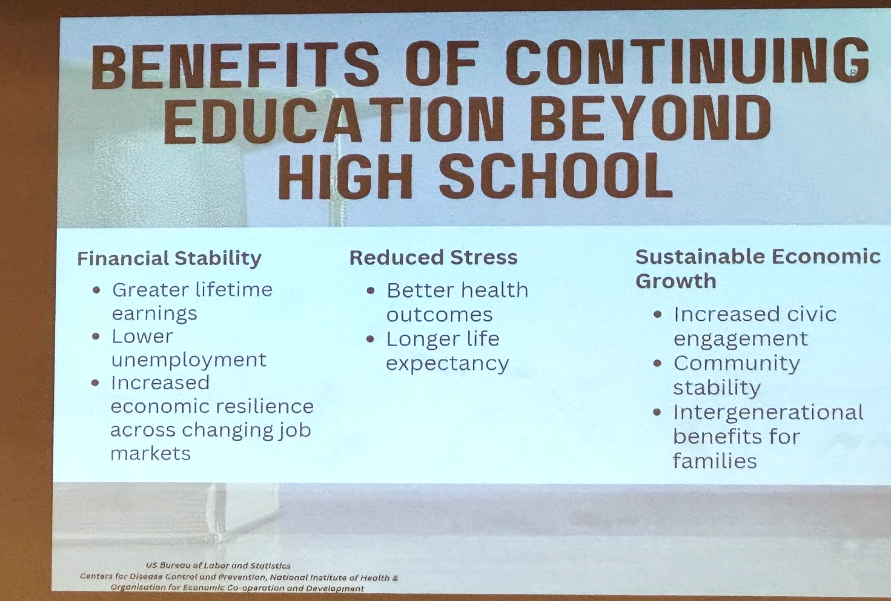

- You have greater lifetime earnings, lower unemployment, increased economic resilience.
- Matter of fact, during the, uh, recession of 2008, 80% of the jobs that were lost were lost to those people that had a high school diploma. People that had education beyond high school were able to rebound, but those who stopped their education in high school really struggled to rebound in that great recession.
- It reduces stress because you have typically better health outcomes. You have typically access to health care earlier. You don't have to wait until it's so bad that you need to go to the emergency room, you get early care, preventative care, and you have a longer life expectancy.
- As was mentioned earlier, it also sustains economic growth because there's more civic engagement, there's more community stability, and there's intergenerational benefits for families.

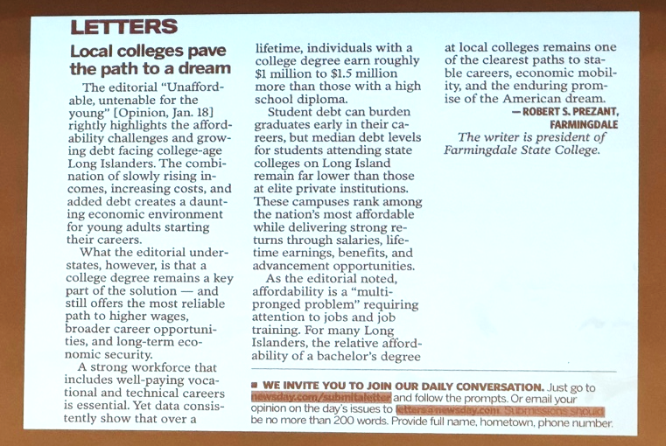
This is a letter that was in Newsday back in January. It was written to the editor and it was written by the president of Farmingdale State College. I don't expect you to read it from the screen. I took the liberty of pulling out the salient points from, uh, uh, President Prezant.

Local colleges pave the path to a dream

The editorial “Unaffordable, untenable for the young” [Opinion, Jan. 18] rightly highlights the affordability challenges and growing debt facing college-age Long Islanders. The combination of slowly rising incomes, increasing costs, and added debt creates a daunting economic environment for young adults starting their careers.

What the editorial understates, however, is that a college degree remains a key part of the solution — and still offers the most reliable path to higher wages, broader career opportunities, and long-term economic security.

A strong workforce that includes well-paying vocational and technical careers is essential. Yet data consistently show that over a lifetime, individuals with a college degree earn roughly $1 million to $1.5 million more than those with a high school diploma.

Student debt can burden graduates early in their careers, but median debt levels for students attending state colleges on Long Island remain far lower than those at elite private institutions. These campuses rank among the nation’s most affordable while delivering strong returns through salaries, lifetime earnings, benefits, and advancement opportunities.

As the editorial noted, affordability is a “multipronged problem” requiring attention to jobs and job training. For many Long Islanders, the relative affordability of a bachelor’s degree at local colleges remains one of the clearest paths to stable careers, economic mobility, and the enduring promise of the American dream.

— Robert S. Prezant, Farmingdale The writer is president of Farmingdale State College.

This one in particular was part of the reason we're here this evening because we hear in the news all the time how crushing student debt is and how it makes it difficult for young people to stay on Long Island, afford a home, uh, afford to buy a home, etc.

So, um, we're going to present the proposed plan tonight that we think can help a lot.

And so as I was thinking about, um, this work and this opportunity, only about two and a half weeks after that, there was this article on Newsday that many of you probably know of or heard of Dr. Oz, you’ve seen him on TV in years past; presently, he was appointed by President Trump to be the administrator for Medicare and Medicaid services, and the headline in this article was “Dr. Oz Pitch” was to “Delay Retirement.” He was recommending that all Americans delay retirement for a year. There were several reasons for that recommendation. Among them is worrying about how long Social Security can pay and obviously if we all delay our retirement by a year the money can stay a little longer.

This article was originally in The Washington Post and then reprinted in Newsday. And again, it's, I don't expect you to be able to read it, but I pulled out some points from related to why we're here this evening.

“Those with a college degree and higher income tend to retire later having more savings and live longer. Researchers have found they're more likely to be interested in their work and see it as part of their identity.”

“People who didn't attend college or earn less have a vastly different experience. They're more likely to work in physically demanding roles, retire early, have less savings, and even die sooner.”

So you don't have to look far to find data and research that shows us what the benefit is of continuing your education beyond high school. And as you saw from the earlier slide, no matter how far you go, even an associate’s degree, even that enhances the quality of your life and the ability to earn more over your lifetime.

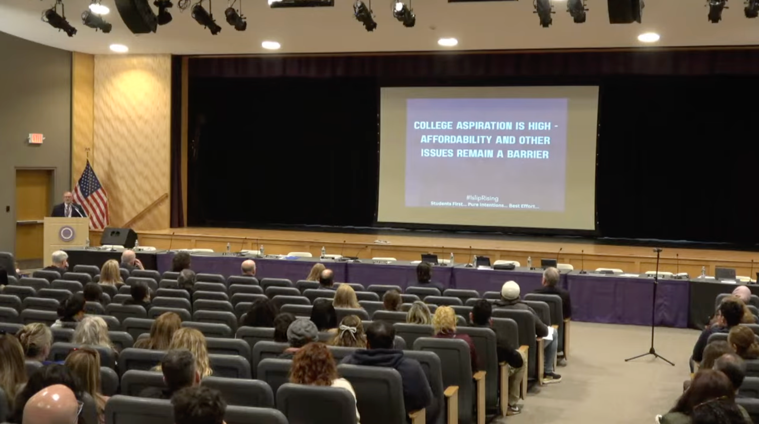

So the question is if it were easy why doesn't everyone do it? If people aspire to go to college and you can clearly identify the benefits, what gets in the way? Well, some of the barriers are costs. Some of the barriers are advisement. Some of the barriers of people just don't have the money [unclear?].

So this is a fact. I, I, find this this statistic shocking because it's just not what people would think of. At least not what I think of. But nationally, if we took 100 high school students and started them in a four-year college in September, fewer than four of them would have their college degree four years later. And that contributes to the problem because people budget for a four-year college degree and then they find out that their child ends up spending five years or six years at college, having spent 50% more for that college degree than anticipated.

And, uh, not because of the efforts of the people that are with us this evening, but due to many factors, but another statistical reality is that if those same 100 students started at a junior college, the completion rate four years later is even lower.

Now one of the reasons for that is because not everyone who begins at a junior college goes there with the intention of earning a four-year degree. There are many amazing programs at junior colleges, in particular, you'll hear about many of them tonight from Dr. Bonahue. People go to junior college because they're interested in becoming a certified nurse assistant or learning about medical billing or phlebotomy, things that will help them earn a living and get into their workforce rather quickly. You don't necessarily need a four-year degree.

Part of the problem people who started the junior college and don't get to four-year degree is because they don't necessarily get the proper advisement. Sometimes there's remedial courses that are required and they don't get credit and then they get discouraged, and then other times they just run out of money that they don't necessarily have.

Rising tuition fees, housing, and textbooks have created significant debt burdens for their families and without careful planning students accumulate credits that don't apply to their degree, increasing both time and cost.

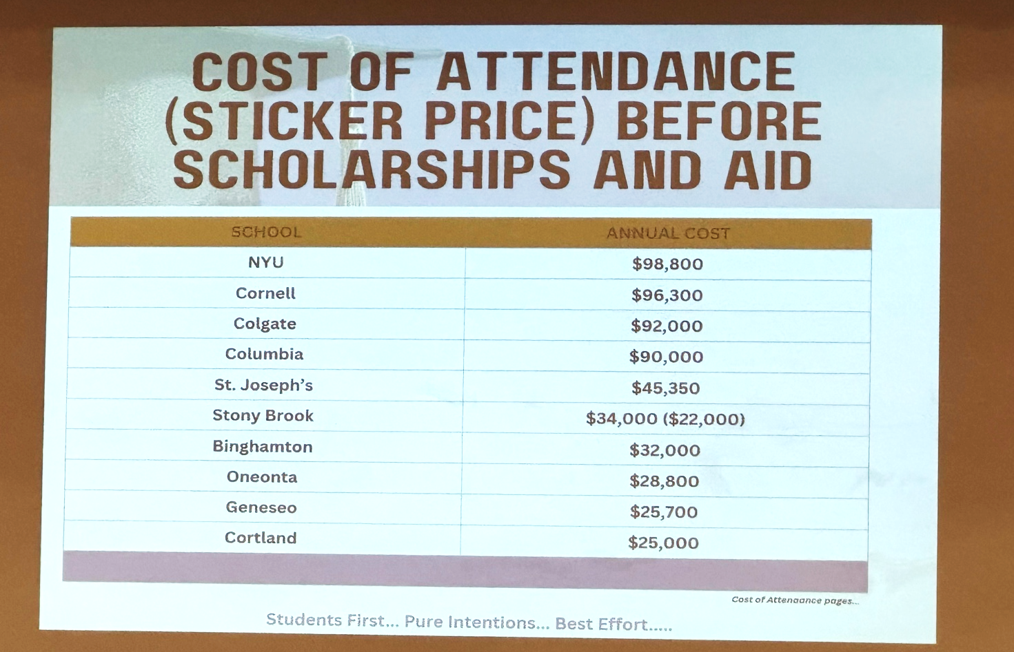

Here's another big reason people don't think a college education is important. The top of this list is five, um, private schools in New York and the next set of schools is five SUNY schools in New York. You can find this information on their websites or by simply googling it. This is the total cost of attendance for one year at these colleges or universities. Now, to be fair to them, that includes everything. That includes books. It includes tuition. It includes gas that it costs to, to, get there. It includes parking the car on campus. It includes your meal plan. It includes clothing. Incidentals. Regardless, you can see it's a hefty price tag. And that's, that's daunting. And it forces many families to say college education may not be for us.

But there's hope—because we have guests here tonight who are going to tell us what Suffolk Community College has to offer. While the tuition at Suffolk County Community College is presently approximately $6,050 for one year, this is what it may cost if you had to commute from Islip, if you had to buy your books, if you had to pay college fees, etc. So trying to compare apples to apples, this is approximately the total cost of attendance for one year in Suffolk County Community College.

So that's the bad news. The good news is we think we have a plan that can really, really, really help with this. I'll say it again and I will say this several times later in the evening. It won't be easy, but it will be worth doing. And we think we can save families tens of thousands of dollars if they're willing to get on board with this and the children are willing to work hard and willing to partner with us. But before we get to the details of how we think we can work, it can work, um, I'm going to ask Dr. Bonahue to come up and spend some time talking to you about, uh, the college where he's the president and everything it has to offer our students. And with that, Dr. Bonahue.

SCCC PRESIDENT ED BONAHUE >> Thanks, Dennis. Good evening, everyone. So, uh, my name is Ed Bonahue. I am the president of Suffolk County Community College, the best community college in the SUNY system. Thank you very much.

And I'm here really for two purposes tonight. One, I'm here to refresh your memories about, about, Suffolk—about everything that we do as a comprehensive community college. We're very proud of our entire mission. We serve over 30,000 students per year. Everything from students learning the English language or taking a high school equivalency diploma to students who are taking vocational education. They're earning a workforce certificate. And the largest portion of our, of our, student body tells us what I really want here is the first two years of university. What I really want is to be able to transfer to university. I want to ultimately earn a bachelor's degree. And there are many roads to that bachelor's degree and I'll talk about some of them tonight.

Um, we were hit hard by Covid. I started as president in 2021 and we, uh, at that time we were really hit hard. Uh, our families were more likely to be affected, but since 2021, our enrollment has grown by 15%. Um, and as I mentioned, we're back to the point where we're now serving, uh, over 30,000 credit and noncredit students every year.

About 15% of all Suffolk County students graduating high school come to us at Suffolk. And, uh, we have we have over 25,000 credit students. That includes both, uh, students on campus and it includes the credit students who are taking courses while they're currently in high school. Um, and by our size, we are by far the largest community college in the SUNY system.

As I hope you know, we have three campuses. The closest one here is, uh, the closest one here to Islip is our Brentwood campus up the road. Um, but we also have, uh, a campus in Selden, and a campus out in Riverhead. All three campuses are full-service campuses. We have all kinds of arts and sciences classes. They have slightly different lineups when it comes to their workforce programs. About three quarters of our students — um, who's seen our commercial on TV? Who's seen our commercial? Good. I'm glad some people have seen our commercial — about three quarters of our students tell us that their ultimate goal is to earn a bachelor's degree. And so, we're very proud, even in our commercial, we feature these students many times.

We talk about the path that they've taken. And, again, they transfer from Suffolk to some of the most selective universities in the country. We're very proud of these students. We also transfer more students to Stony Brook, obviously a destination of specific interest here in Suffolk County. We transfer more students to Stony Brook, I think, than all the rest of the community colleges combined. And so we're very proud of that. We have joint admissions programs with many universities, I think Dennis may touch on that later, but, um, we're especially proud of Sea Wolves at Suffolk. Uh, so Stony Brook's mascot is the Sea Wolves — who here went to Stony Brook? Yes, plenty. Right — and um so Sea Wolves at Suffolk is a program whereby we can begin getting students oriented to Stony Brook even while they're on campus. Uh, I mentioned that we're very proud of the articulation agreement. We transfer students all over the country uh including many selected universities. Here are just a few.

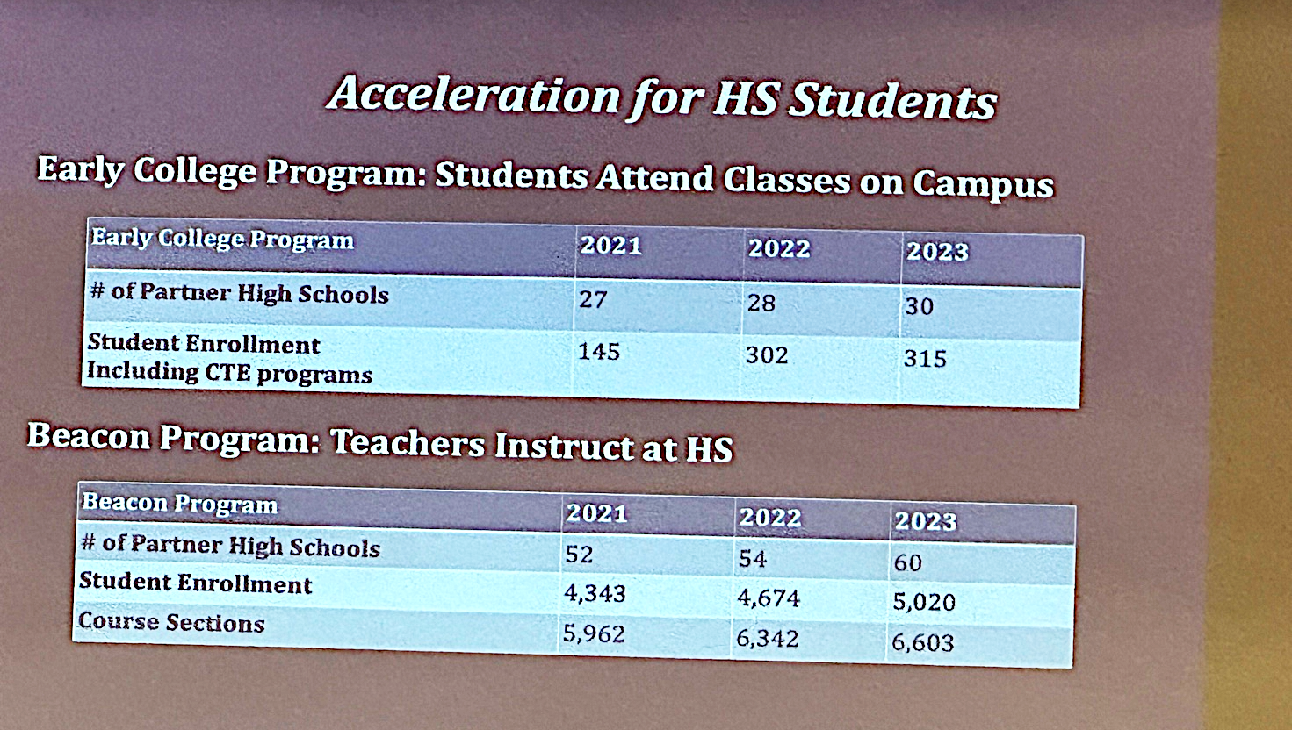

Independent of this presentation, uh, about the, our, joint programming with Islip, I always mention the fact that we have so many students in in high school who are already Suffolk students—including some here right here in Islip High School. We partner with most of the school districts in Suffolk County. We have, uh, we offer high school programming in two forms, both, uh, taught by, uh, faculty who are in the high schools including many, uh, Islip High School faculty, and we offer Early College programming. Early College means that the students come to us. And students are actually taking courses while they're still in high school, but with our college faculty, they can do this online or they can take these classes on campus. And you can see there we partner with virtually, uh, I think there's 65 districts in, in, Suffolk County. And obviously we partner with almost everyone that has a high school.

About 25% of our students tell us, "What I really want is to get a job. I'm, I'm, less interested in getting a bachelor's degree right now. Maybe someday, but right now, what I really want to do is get a job. I want to enter the workforce." And we're really the regional training center for a lot of industries. Our I'm going to talk about some, uh, flagship programs in a minute—everything ranging from automotive to nursing to welding to cybersecurity. Uh, these are really large programs and, again, students come out of these programs with multiple job offers and many times there are certificates they can complete on the way. It can be a certificate and then a degree and then they can go on to a bachelor's degree as well.

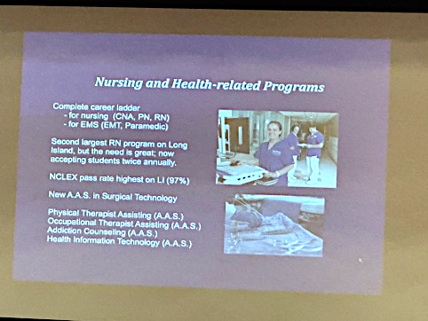 | 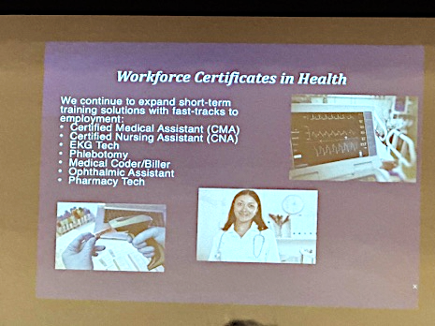 | 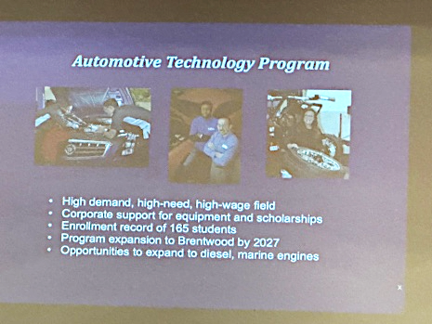
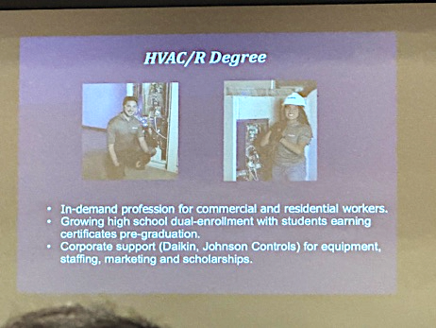 | 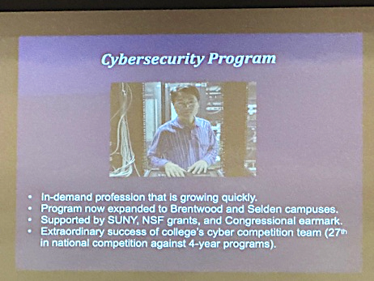 | 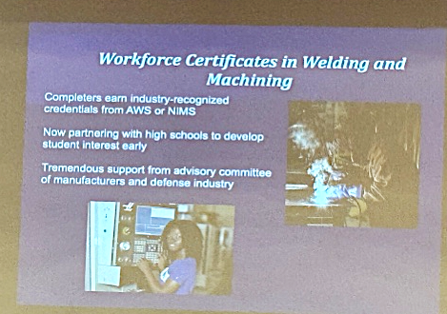

These programs, the programs, I'm going to talk about on the workforce side are possible destinations for students who are in the Beacon program. Uh, a student who already has some high school credits, uh, some college credits that they earned in high school, will be able to have an easier time accessing, for example, a degree in healthcare once they get to campus. But we do not offer these, um, these CTE programs through the Beacon program. We are the largest provider of — I, I don't know if people know this? but we put more nurses on the hospital floors in Suffolk County than any other college or university. We're currently putting about 150 RNs on the floor of our local hospitals every year. We have a program to, uh, we have a plan in place to try to grow that number of RN students. We're now accepting students into the RN program twice a year as opposed to once a year, and we're trying to manage that a little bit differently so that we can increase our output.

We also offer the complete ladder for folks who are interested in nursing, moving from, um, a one semester certificate or being a certified nursing assistant to the, uh, licensed practical nurse credential, which is shorter than a degree but it takes, takes, a few semesters to get through it, and then all the way to the, uh, RN program. Our NCLEX rate uh our NCLEX pass rate is the highest on Long Island. We're very proud of that.
It's a credit to our faculty. Uh, also in health sciences, we have a new degree program in surgical technology. These are the folks who assist with instruments in the operating room, physical therapy assistance, OT assistance, addiction counseling, um, paramedic programs, uh, EMT training. We are the largest trainer of allied health and nursing professions on Long Island.

You guys, again, not every student wants to earn a degree right now. So, they may graduate from high school and maybe they say, "You know what? I really just want to get started quick. I have a sense of urgency." Um, guidance counselors, parents, teachers, if you have if you know students who they really have a sense of urgency, they want a short-term certificate that they can immediately, can convert to full-time work, we offer medical assistant, nursing assistant, EKG and phlebotomy technician, medical coding billing — Legislator Flotteron, thank you for connecting us to a business, uh, nearby here, uh, for our students who are in the medical coding billing program — um, assistant pharmacy tech. Again, these are shorter than degree programs, but students come out of these programs usually with offers for full-time employment.

We're very excited about the status of our automotive tech training program. Uh, and automotive technology historically has just been located at our Ammerman Campus, off Nicolls Road. With support from both the state and the county, we are doubling the size of that program. And by 2027, we will open a new automotive technology program at the Grant Campus in Brentwood. So a student won't have to go all the way up to Selden. Students from here in Islip, students from western Suffolk County, will be able to access the automotive program right here in Brentwood.

Also in Brentwood is our HVAC degree. Again, uh, HVAC folks are very in demand, whether you want to do retail work, visiting, visiting folks homes to do repairs, or doing things like building engineering, working for hospitals, schools, businesses, doing, um, the kinds of engineering work in climate control that our students are trained to do. We're so grateful for that. We have corporate support from Johnson Controls,
from Dyken, and from other companies that help be sure that our students are trained on the latest equipment.

Uh, cyber security has been much in the news in recent years and, uh, we're very proud again that we have a flagship cybersecurity program. Um, it is also with the help of an earmark from, it actually started out with Congressman Zeldin when congressman, when he was a congressman, uh, we, we had some congressional support for program expansion that led us to expand the program from Selden to the Brentwood Campus. Um, uh, and, and again we offer a co-curricular student team that's had really extraordinary success competing against four-year universities. So we're very proud of that.

For students who want to, um, there, there are many things that students can do after high school. We talk to students many times and they want to they want to learn a trade. They want to work with their hands. Um, many times that involves that that might involve one of our partners in labor. It might involve getting involved with an apprenticeship program or a journeyman program with one of our, our labor partners. But also on campus, we offer certificates in welding and CNC machining. Both are very in demand. Uh, we also have tremendous support from the US Navy. Um, if you've ever seen the commercials for build submarines, builds, you see them at sometimes at like the football games, there's a commercial for build submarines. That's us. We have support from the US Navy in the form of scholarships to pay for students who want to learn to be a welder or be a machinist, so long as they're willing to make a commitment to a certified defense
contractor, certified defense manufacturing contractor. And we're actually going to be celebrating our manufacturing community on Thursday night at the, at our annual Foundation Gala. We're proud of that.

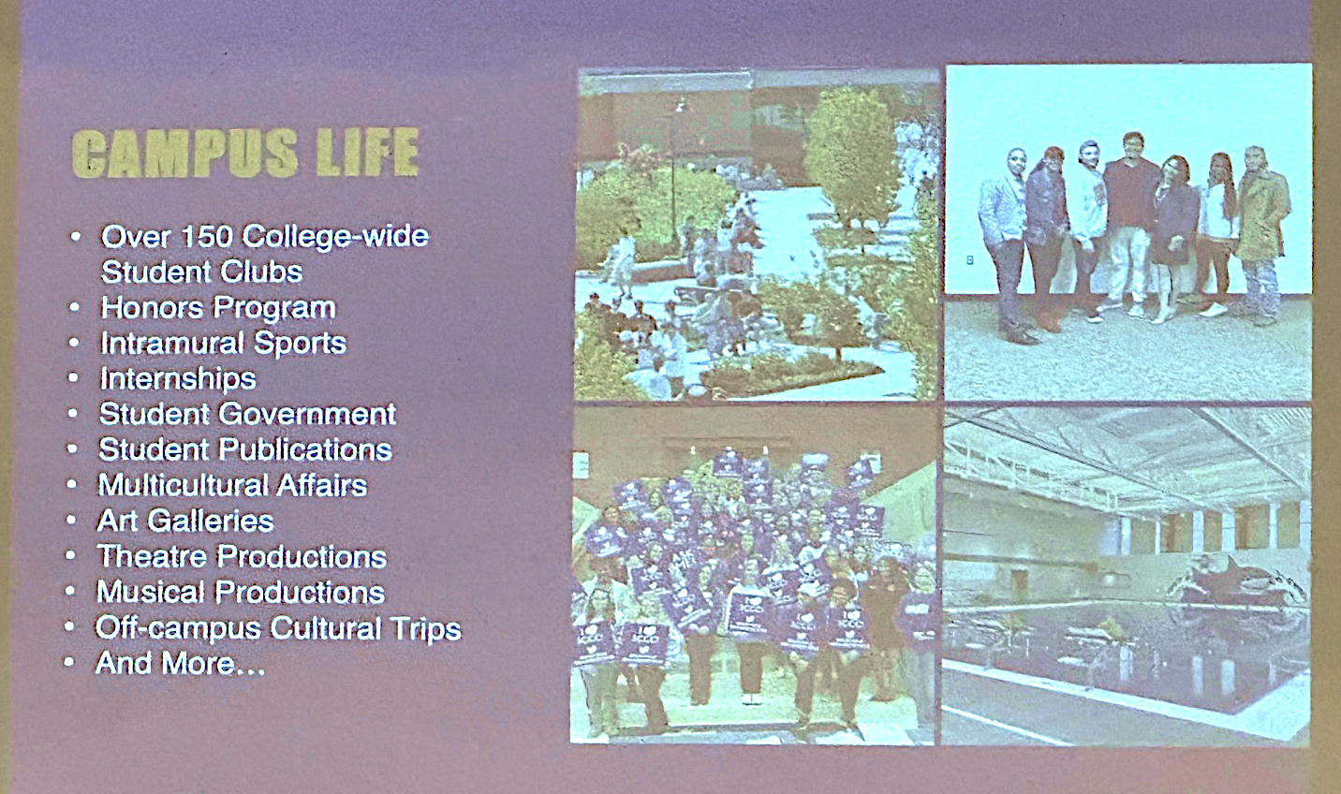

In terms of campus life, uh, you know, I, I'm not positive that everybody knows that as a, as a comprehensive college, we're a college. We're a college. We offer athletics and a student newspaper and a radio station and student clubs and, uh, you know, social events and the art galleries and music and theater and so forth. And the research shows that when students get involved in these events on campus, they succeed. One of the one of the things we'll be talking about in a moment in terms of the joint programming with Islip is, is, that we want to promote more on-campus opportunities for students. There's always going to be credit that students can take while they're in high school, but we also want to promote students coming to campus because one of our goals is to be sure that they understand that they belong in Suffolk, that they have a home at Suffolk, and that, um, uh, when they are involved on campus, they're far more likely to complete their degree program.

Uh, in terms of scholarships — Dennis, thank you for commenting on the affordability, uh, the affordability factor — uh, one of our trustees is here, our Board of Trustees is always committed to trying to keep our enrollment [tuition] as low as possible. As you heard, right now $3,000 a semester, $6,000 a year, compared to our colleges in the university system who, who, have to charge a bit more. Um, we offer right now over $600,000 a year in scholarship support for students who matriculate to the college. So, if you come to the college as a college student, then we're able to, uh, again, help with what we hope is already an affordable tuition, uh, with some scholarship opportunities as well.

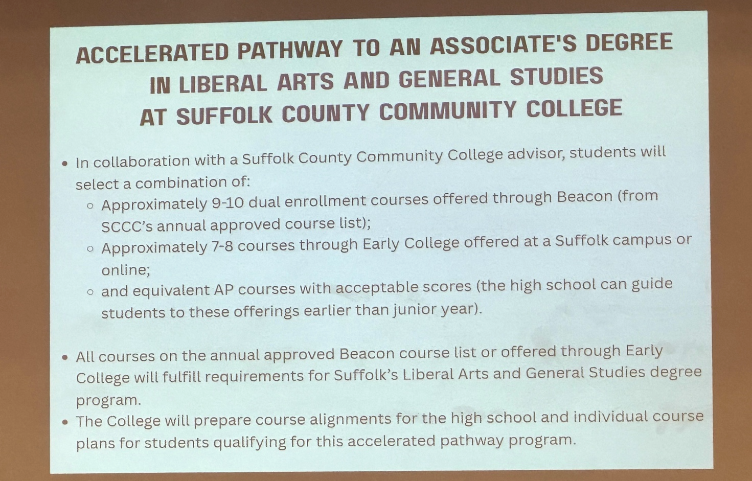

Now, we're going to, I'm going to pivot. Let's talk about the accelerated pathway that, that, we're really here to talk about tonight. Um, we're, we always want to increase student access to college. That's one of our goals. We also want to increase, um, the yield that we get at the college from our, our partner high schools. So, we're very excited with the idea that we can make our pathways to a degree program more visible, that we can, um, share information with students even while they're in high school about the possibility of coming to Suffolk and earning a degree right with us in Suffolk.

Um, I, I do want to emphasize that this is a highly regulated area, that we have, um, SUNY set standards for us, the state education sets standards for us, and Dennis, thank you for being so understanding. So far, uh, with Dennis and his leadership team and me and Dr. Rios and our leadership team, we've had one conversation really about the details of this program. But we're so excited that we're ready to bring, to bring it to you as an as the outline of a plan. There are more conversations that need to happen.

Uh, we're, we're going to answer questions. You're, you're, you may be giving us suggestions for things that we need to do, things that have not yet been done or not yet been addressed, um, but we're excited about it and so we're here to put it in front of you. Um, I do want to mention that, I, I need to say that historically and under the state guidelines, we are a college that is able to open Beacon program to students who are juniors and seniors. What we have to, what Dennis is going to talk about in a minute, is a pathway that gives an additional pathway into the Beacon program.

Um, there are also eligibility requirements. There are eligibility requirements that students have to meet to be in, uh, the Beacon program. And again, we'll talk about those eligibility requirements.

The way that we have envisioned this program requires cooperation that students will take a certain number of credits in the high school and also and envision that they will take a certain number of credits in the college, and you can see these you can see these, uh, parameters, uh, here on the screen, uh, and combining that with AP coursework we're excited that students will accumulate more credits, they will be able to make more progress towards a degree, and by offering more intentional information about college degrees we'll be able to, uh, we'll be able to put more students on the pathway to a degree, uh, that they can then finish at Suffolk Community College.

Um, we have had one student in the last five years, during my tenure as president of Suffolk, we've had one student who has succeeded in finishing an associate’s degree while they were still in high school. We're optimistic that there could be more. We have to figure out how to do it.
So under this collaboration, again, we see this as a, a joint program, joint programming that will involve both
Beacon courses and community college courses. I want to say that much — and we'll be, we'll be glad to respond to questions at the end of the presentation. So, Dennis….

ISLIP SUPERINTENDENT DENNIS O’HARA >> Okay. So, we're going to transition a little bit to tell people what we believe is possible.

And, uh, listening to Dr. Bonahue who I'm reminded of a quote that used to be on the wall in my wrestling room when I was in high school. It said, uh, the difficult we do immediately, the impossible takes just a little bit longer. So, we're, we're here tonight to tell you that we think we can accomplish great things with our students and with Suffolk County Community College.

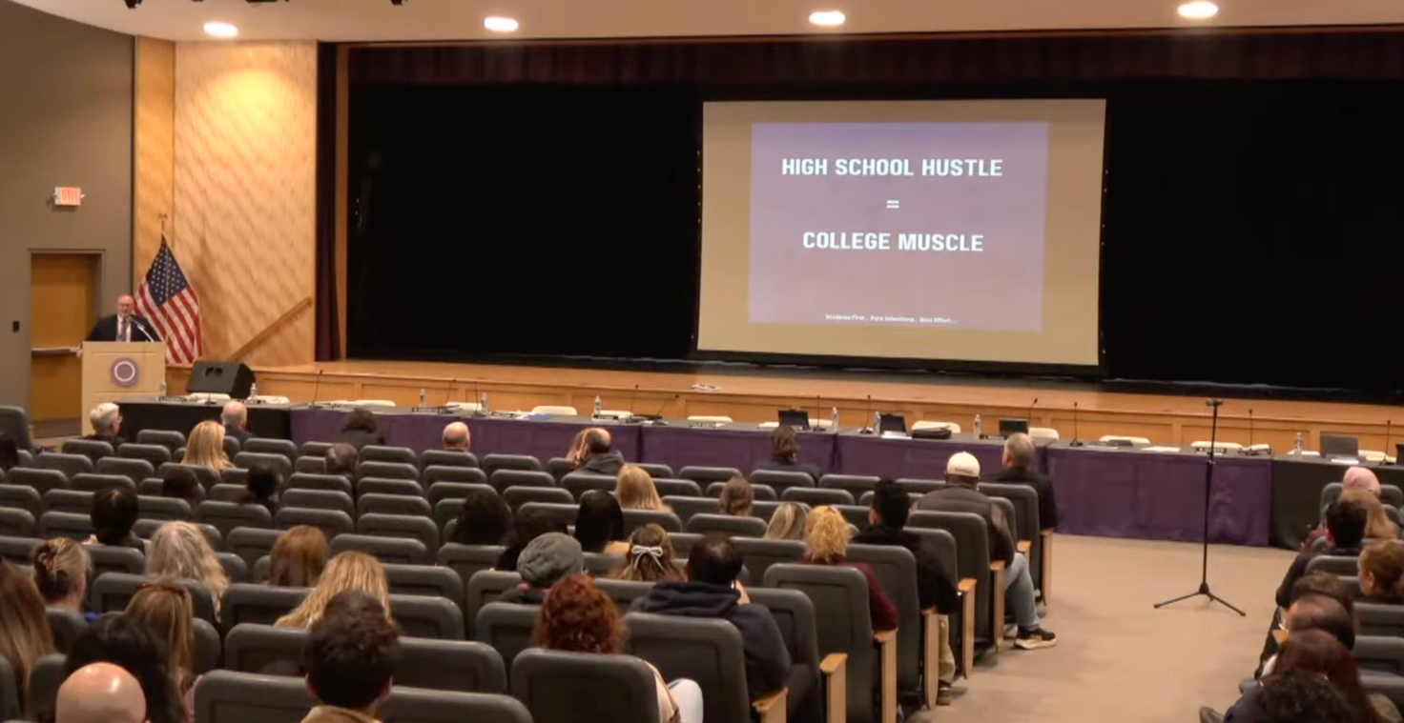

So, high school hustle equals college muscle.

Uh, I just want to take a moment to share this letter. I don't expect you to read it. You may not be able to, but it comes from uh, the, uh, Suffolk County Executive, uh, Mr. Edward Romaine. This was mailed, um, in September to all superintendents in Suffolk County. And while Dr. Bonahue and I were having conversations prior to that, uh, or met prior to that, um, I was very pleased to see this letter from Mr. Romaine and this is, these are the highlights from his letter.

Suffolk County's future depends on the success of our students. I'm reaching out to highlight affordable opportunities available through SUNY Suffolk’s Beacon and Early College programs which allow high school students to earn college credit while completing their graduation requirements. These programs give students a head start on their college education at a fraction of the usual cost. By promoting programs like Beacon and Early College, we can make higher education more affordable, reduce student debt, and help our young people remain, work, and thrive here.

That's directly from our county executive.

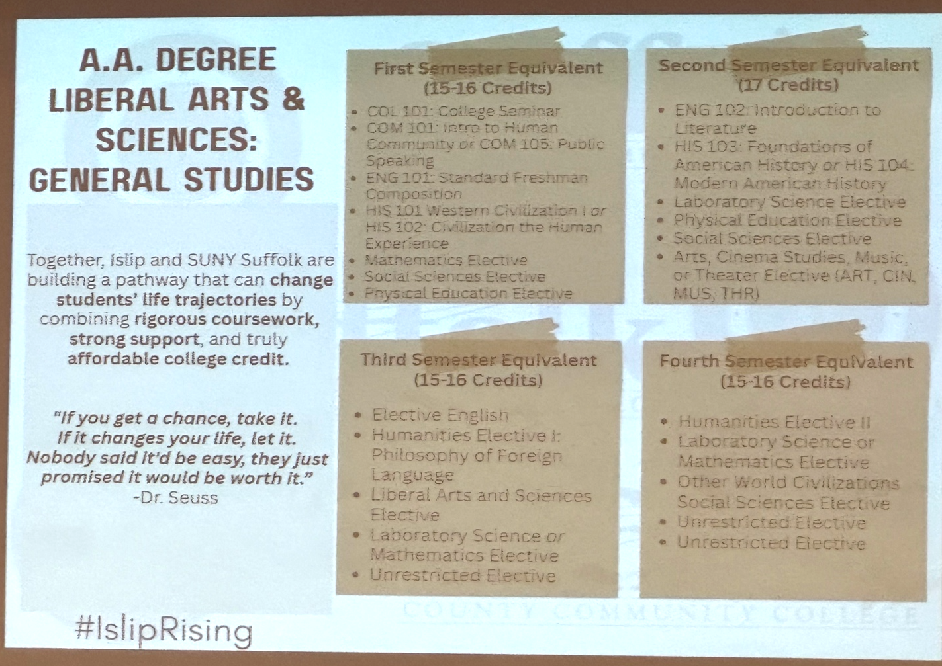

So, um, I don't expect you to read everything that's on here, but this is the requirements for an associate’s degree in Liberal Arts & Sciences: General Studies at Suffolk County Community College. It ranges between 65 and 67 credits, dependent upon maybe some lab classes or, you know, the other courses that you have.

What we've been working on is a pathway that can change students’ life trajectories by combining rigorous coursework, strong support, and truly affordable credit. And I feel like I can't be here tonight and not talk about Oh, the Places You Will Go with Dr. Seuss. “If you get a chance, take it. If it changes your life, let it. Nobody said it’d be easy, they just promised it would be worth it.” We're about to explain something that we think would be really, really challenging but we also think will be very worth it if our students and families step into this.

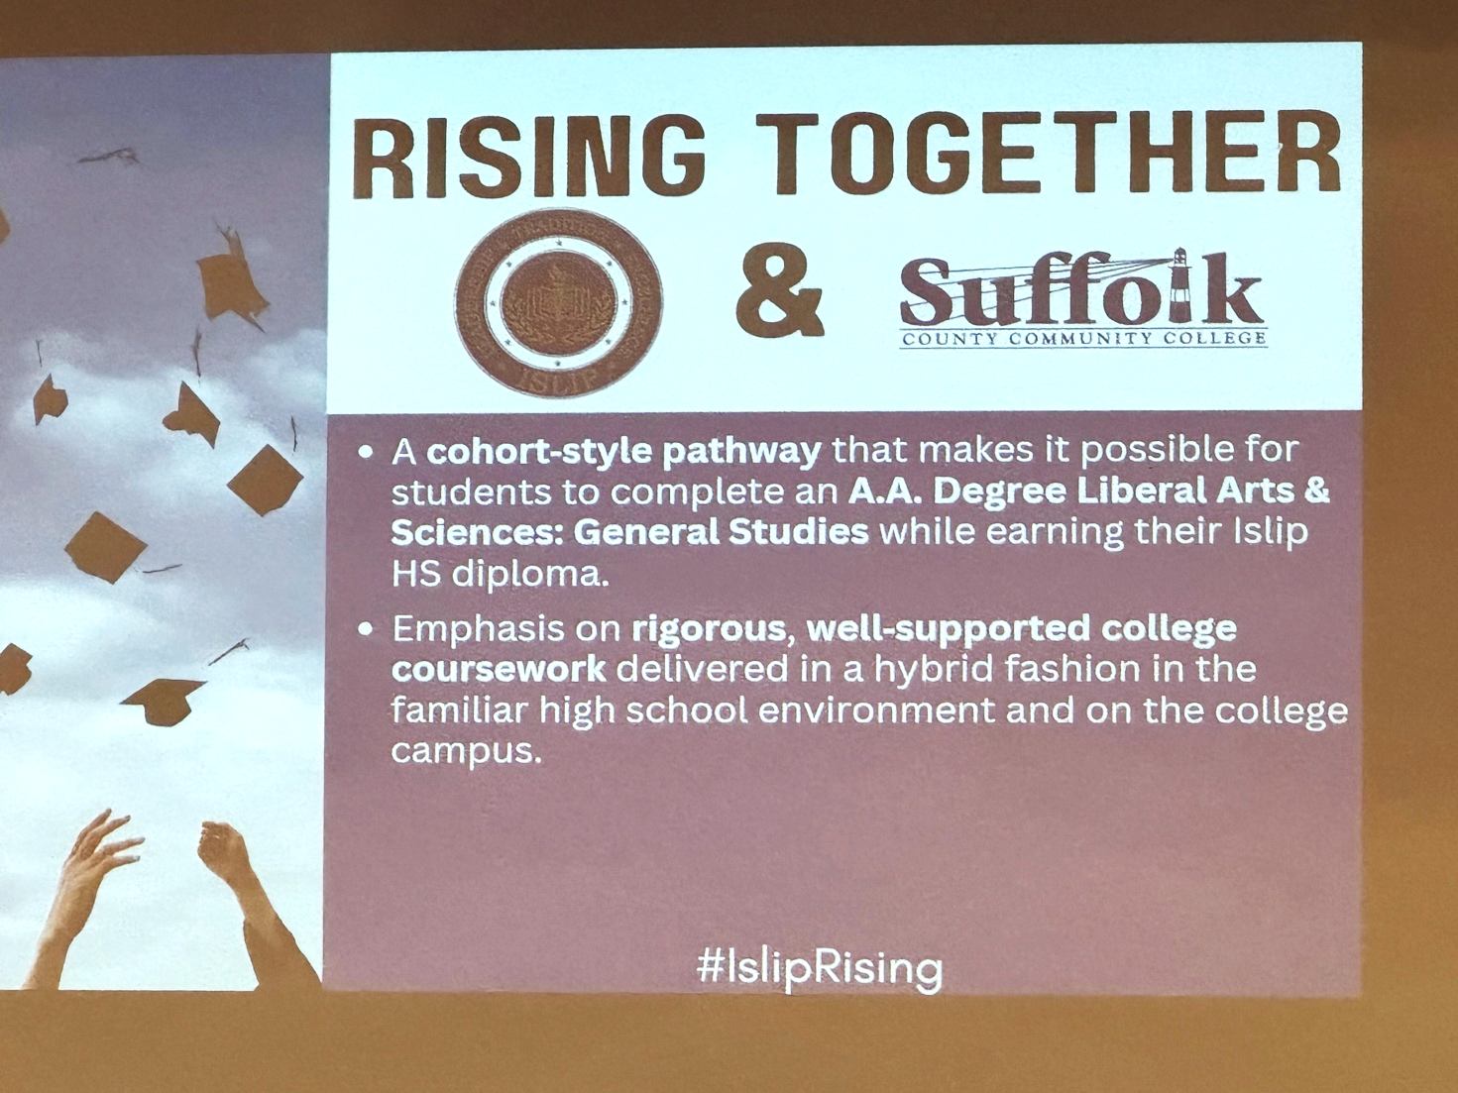

So, we're working on a cohort style pathway that makes it possible for students to complete an AA degree in Liberal Arts & Sciences while earning their high school diploma. And I say cohort style. Cohort typically means you walk into a room of people, and you take every step together, go through everything together. This program will be kind of like a cohort hybrid if it plays out the way we think it's possible.

So students would start together with some summer courses, this coming summer, and then they might go their separate ways depending on the courses they select during their high school years and then they might come back together again the following summer and so on. The emphasis is going to be on rigorous work because this is college-level work. The college has its prerequisite requirements. It has its, uh, course participation requirements, course attendance requirements. All the students have to do work that is satisfactory whether it be our faculty or the college's factory, uh, faculty, all those requirements have to be there.
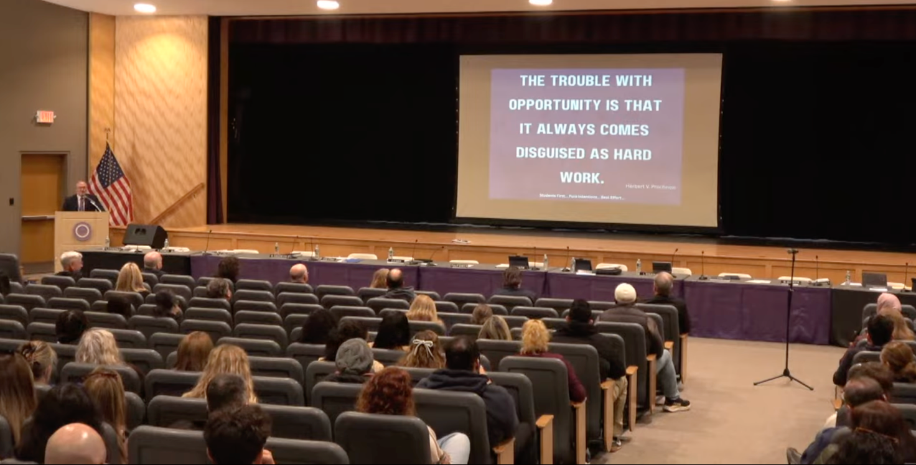
And it's focused on equity and access. So what that means is that this could be available to any student who's willing to put in the effort and do whatever it takes to earn college credits while they are enrolled. Um, but the trouble with opportunity is that it always comes disguised as hard work. So, I'm going to be a broken record and say to you that this is a tremendous opportunity, but this is also going to be a tremendous amount of work.

And here's the beginning of how you start to make this happen. You don't have to memorize this. This presentation will be online after the fact so if you're struggling to take pictures, don't worry, you can get it from our website. You're free to take the photos, of course, but you don't have to feel pressured to miss it.
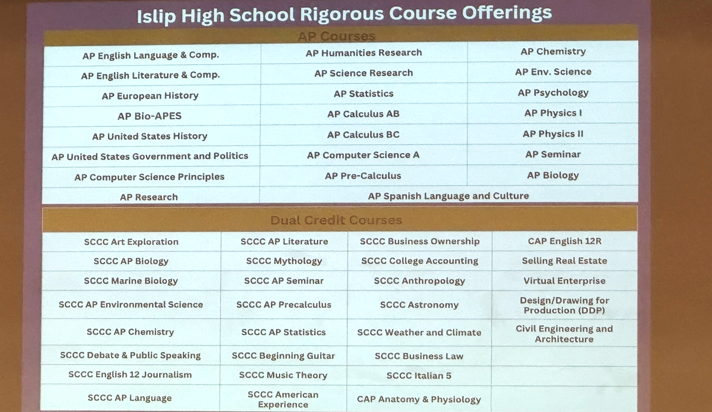

So, these are the advanced placement courses that we presently offer in our high school, and there may be one more coming soon. And these are the dual enrollment courses or dual credit courses that we offer in our high school. And you'll notice almost entirely the first three columns are Suffolk County Community College.

We've, we've worked, um, over the beginning of the school year to transition from some of the other colleges that we used to participate with to Suffolk courses so that it would be easier for our students to transition from their years at our high school directly to Suffolk County Community College — and thinking that if students worked really hard and they earned a year's worth of college credit, these Suffolk credits would transport them seamlessly right through to Suffolk County Community College that would make things easier for students.

Okay. So, what might it look like? These are the students that we're going to kind of focus on this evening.

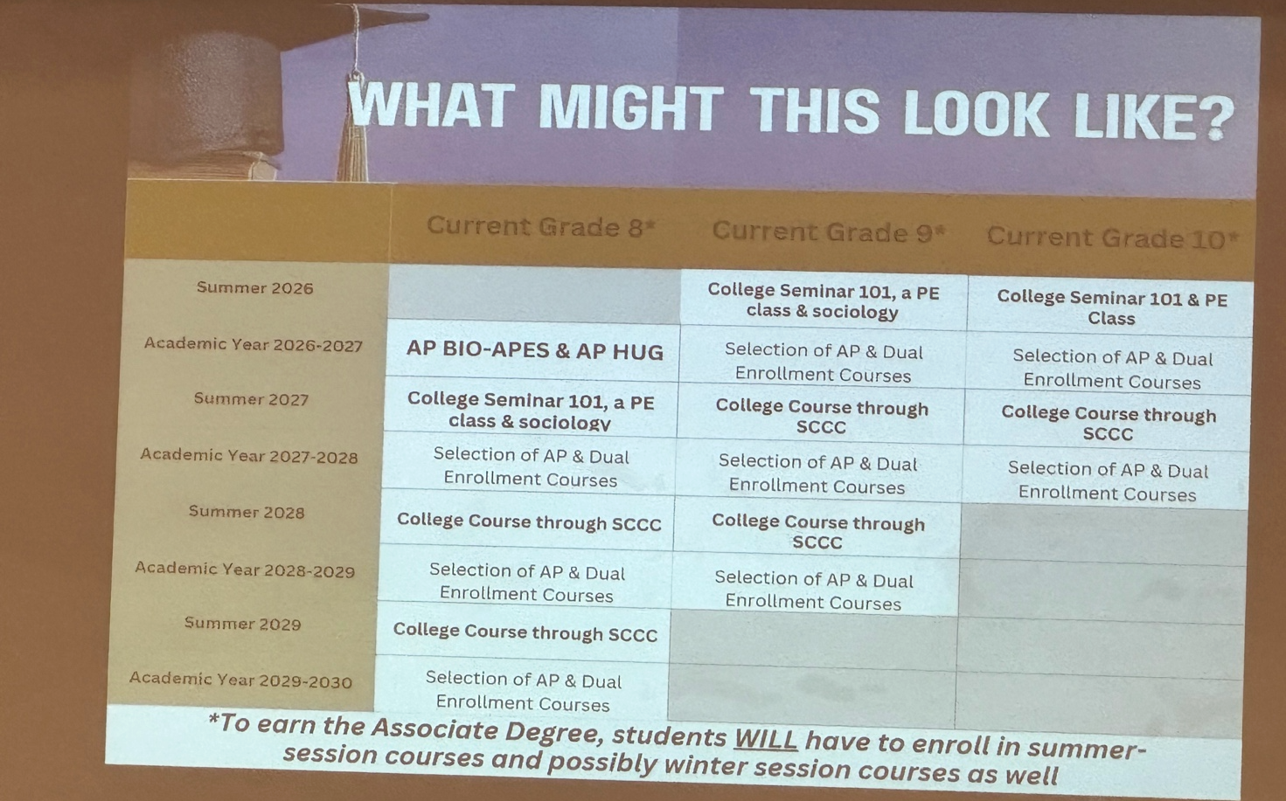

We have the summer of 26, the academic school year that starts in 26. Summer of 27, academic school year begins in September of 27, summer of 28, academic school year of 28-29, another summer and 2029, uh, 2029-2030 school year. So, we're kind of looking at our 9th graders as if they're cohort one for this proposal.

Then what we'd like to try is to find a group of hearty, hardworking, committed, dedicated, and resilient students to begin after 9th grade with a college seminar course, which is one credit, a PE class, which is one credit, and possibly a sociology course that would be taught by faculty at Suffolk County Community College.

And on our end, we would try to figure out ways to help our students get to the campus for at least two of those classes. And we think possibly the college seminar course could be virtually. And our plan would
include having our students meet together in one of our classrooms and take a class virtually as a group.
Then once it ever rolls around, students would have to be enrolled in some assortment of Advanced Placement courses and dual enrollment courses. So they would have to begin making selections from those two pictures I showed you a moment ago, the AP courses on the top and college courses on the bottom. In the following summer there would be more college courses on the college campus and/or virtually. The summer courses would be the Early College courses and the courses during the school year would most likely be Beacon courses. Then during the academic year there would be more AP courses, more dual enrollment, then we have summer, and for the 9th graders we have their senior year.

Now remember, to make this happen, you have to meet your high school graduation requirements and through a combination of Advanced Placement courses, Beacon program, and Early College courses, and achieve your 65 college credits. 10th grade would be the same beginning and you would follow suit. You just have a little bit less time. So you might be candidates to earn one year worth of credit and maybe continue at Suffolk County Community College for the second year. Still, both have substantial savings over some of the numbers that we, uh, showed on the screen earlier.

Current 11th graders, if you're interested in trying to take advantage of some of this, then we would recommend you join us this summer. And then you would have to do an assessment of your transcript to look at the AP courses you may have already taken and college courses that you may also have already taken.

Now, middle school students cannot participate in college courses, but it's the time of year where middle school students are beginning to select their high school courses. And what they can do is think ahead, look at the offerings we have in our high school, and select these two Advanced Placement courses that are offered to 9th graders.

If your 8th grade students can take these courses and earn a three or above out of a five-point exam, an Advanced Placement exam — three is passing, maximum score is five — you could conceivably earn six college credits through these Advanced Placement opportunities and you will be kind of on your way and then the rest of it would follow suit with what showed.

Same slide, just important information at the bottom to have the possibility of earning this associate degree, students will have to enroll in summer session courses, possibly even wintersession courses, find courses that are available to them in wintersession, summer session 1, summer session 2. So it could mean you'd be in high school classes during the day and you'd be in college classes in the evening.

It's a lot, but we think it's possible. We're going to show you how.

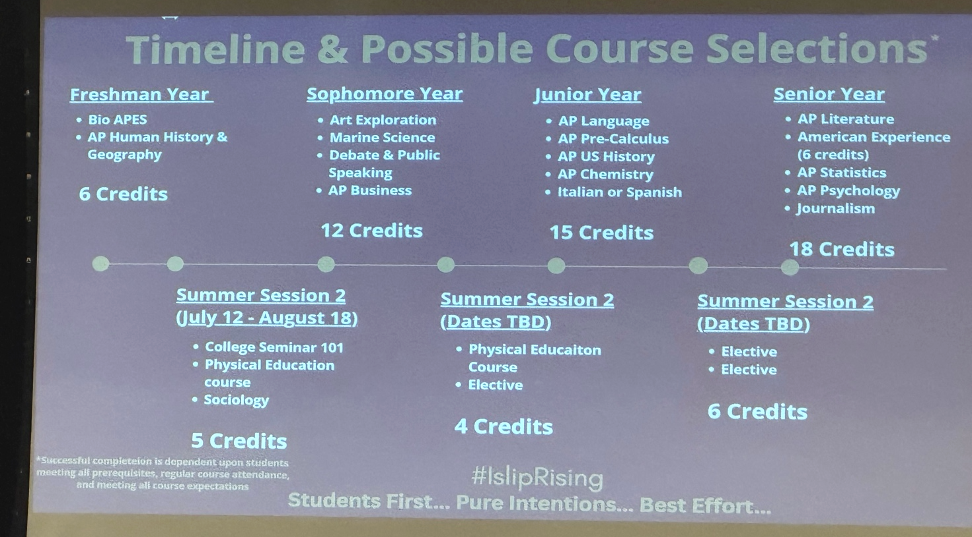

So here is a timeline and a possible course, uh, possible course selections. What I'm going to share with you will not be for everyone. This is just one example of how it's possible, and then every individual student will have to work through based on their abilities, their desire to do the work, and their level of commitment.
So, for example, if you're a current 8th grader, you could begin this timeline with bio AP environmental science. Currently, it's referred to as LEAPS. If you've seen that course, bring your children, and AP human history and geography. Those would be six credits.

We're working with Dr. Bonahue and his team to make it possible for students this summer to earn five credits through Early College opportunities. Sophomore year would be more Beacon opportunities and an AP business course. All of the things that are on here are examples. This is, might not be everything your student tries, but these are examples, these are how we find and achieve the 65 to 67 credits while meeting our high school requirements.

Another summer session, possibly a physical education course, possibly an elective. Junior year, I want to emphasize that if you look at that, that is a heavy schedule. That's four Advanced Placement courses and college foreign language course. It's not for the timid, and it's not for the people who think they could just kind of go through the motions, right? Starting to see how it takes shape. Summer session, two elective courses, six credits, and then senior year, bring it home.

Okay. Uh there is a disclaimer at the bottom. Can you folks read that? Because with my eyes, I can't read the little print on the screen. Uh, basically it says that, uh, this is, uh, um, dependent upon students meeting prerequisites all attendance requirements and of course successful completion of all assignments and requirements in the course and then after that on to even better things.

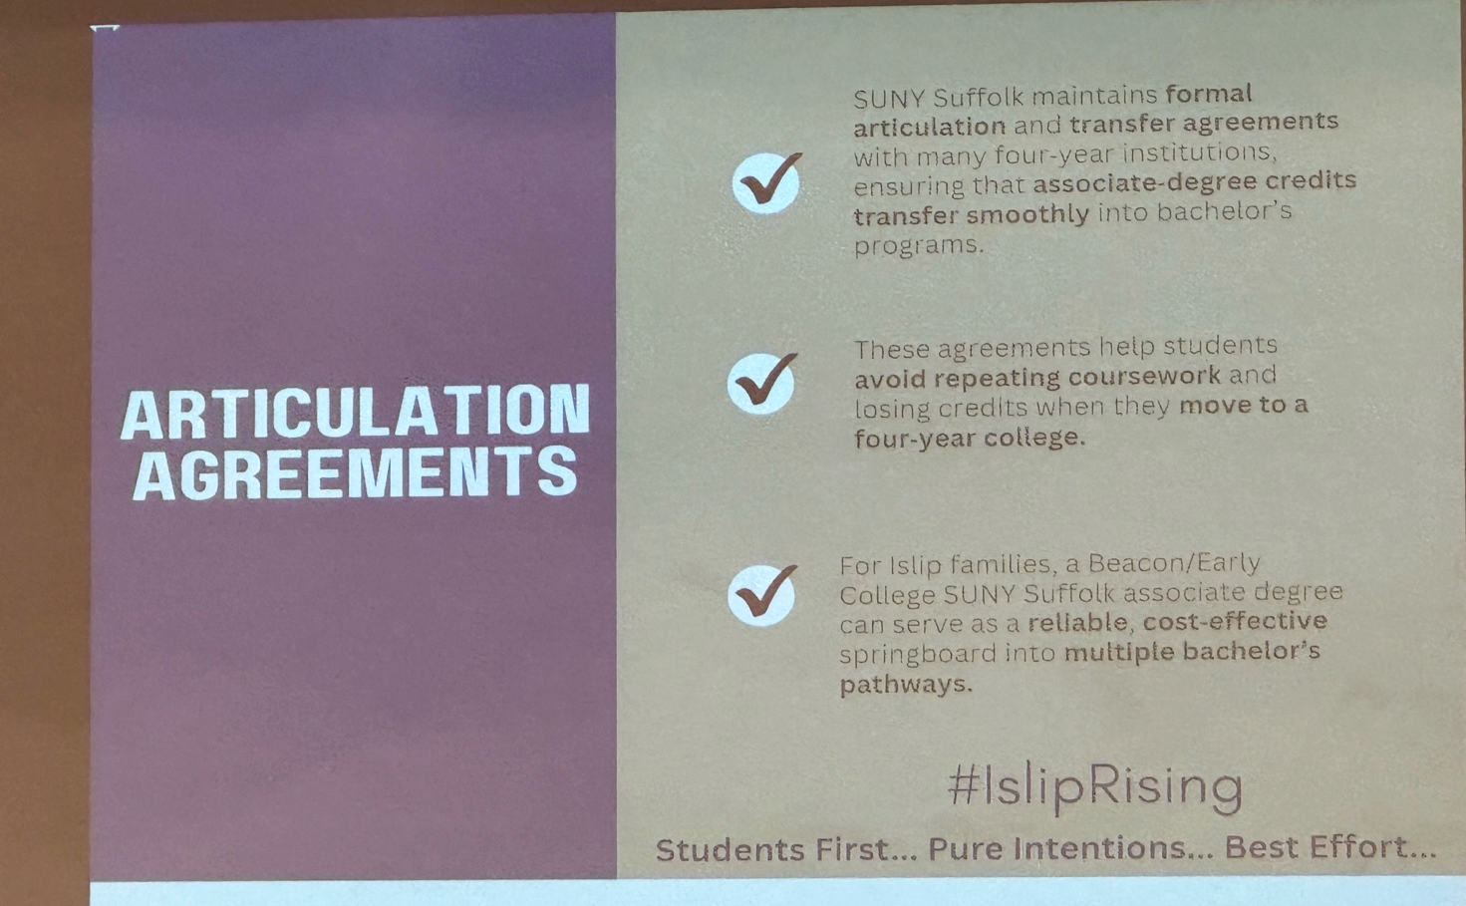
Dr. Bonahue touched upon it in his presentation, but this is why we think this opportunity is so valuable.
SUNY Suffolk maintains articulation and transfer agreements with many four-year institutions, ensuring their associate’s degrees transfer smoothly into bachelor's degree programs.
So what that means is, let's say that you are one of the few who can complete a two-year degree while you're here. You could use that to transfer smoothly into one of the schools that SUNY Suffolk has articulation agreement with.

Let's say that you were one of the more likely cases where you earn a year's worth of credit and then you continue at Suffolk in person for a year. You can still take advantage of these articulation agreements, having paid very little money for your first year of college. And then have paid that assuming Suffolk tuition rate that we talked about more than once, and you can just start to add up how many tens of thousands of dollars it can save you. These agreements help student students avoid repeating course work and losing credits when they move to a four-year college.

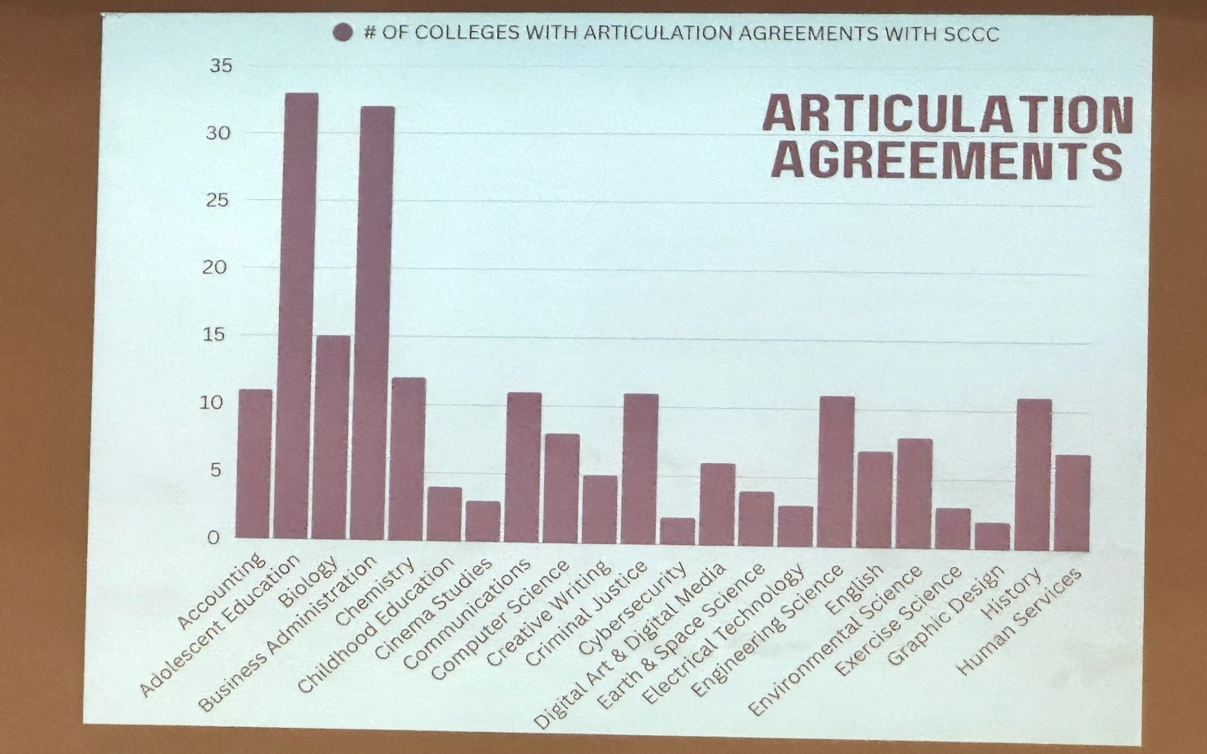
So, we're hoping this turns into a reliable, cost-effective springboard to multiple bachelor pathways for our students. And I just want to give you some examples of the articulation agreements. So across the bottom of the screen, that's a list of the majors that are in the course catalog at Suffolk County Community College. And so for example, the fourth one in is business administration. So if you were to be a student at Suffolk County Community College and mark your major in business, if you graduate with your associate degree and you have the necessary GPA, there are 31 or 32 colleges that you can seamlessly transfer to out of Suffolk County Community College. It doesn't mean you're limited to those 31 and 32, but those, those are seamless transitions. And here's more examples.

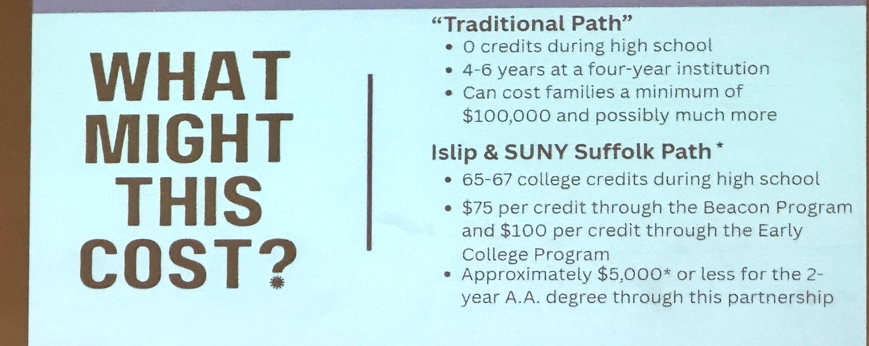

What might this cost? I can't predict what it will cost because that'll be variable. That will vary by every student. But if you go to a four-year college, and don't do any college credits, I have up here that it's a, a, minimum of $100,000, but I don't even think that's accurate. I think it's probably more than if you start a four-year college by the time you go.

But if you work with us and we continue to develop this program, you can earn your credits in high school. It's $75 per Beacon credit, $100 per credit for the Early College program. So, it could cost $5,000 or less to earn 60 or so credits. And then you would add on the cost of your two-year degree, your remaining two years. But of course, the final course would vary by how many credits you earned, the course selections you made, financial aid, transfer destination... but, regardless, this is this is a great opportunity for families.
Okay. Now, this looks like a repeat, but I just want to kind of explain to you where the savings could come in here.

Um, many of you may be aware, but if you're not, let me just remind everybody that in this school district in particular, we pay the AP exam fees for every student that takes the test. So, in this first year, if you take those two AP exam fees, uh, excuse me, if you take those two AP courses, you have the potential to sock away six college credits, and it would cost you zero because we pay for the exam. So, you earn three and above, you have six credits. And it was uh thank you to the Board of Education, the taxpayers of the Islip school district.

If you take these five credits over the summer, because they're $100 per credit, it's $500. And this, uh, the way this proposal works, that's three Beacon courses. That's $75 a credit, $675. Coming back down here for a summer of four college credits, $400. Heavy load of AP classes and one college course, $225. Six credits with Early College, $600, and some AP classes and some college courses, $450.

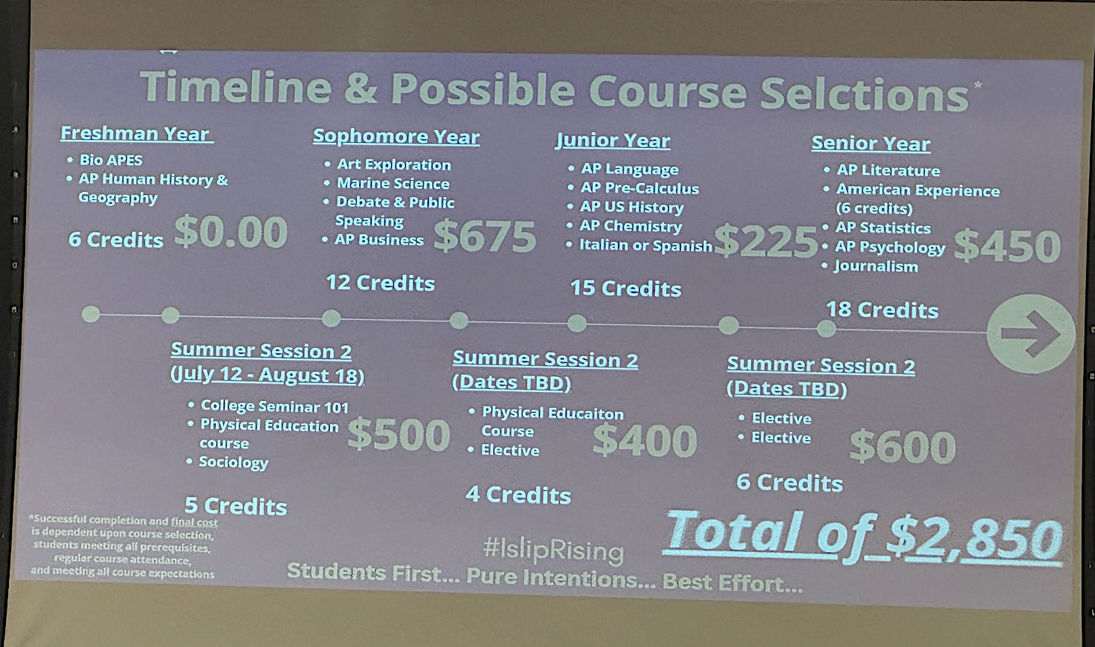

I don't know if you can tell, but that's what's reflected on the screen in terms of cost. Now, um, you can't hold me to that number because this number, this number is based on 10 Advanced Placement courses which is a heavy, heavy load. 10 Advanced Placement courses in four years. That's the maximum 30 credits that you can transfer from AP courses. So it's a heavy load. So if you're a student who's not ready for two AP classes in 9th grade, it doesn't mean all is lost. We'll try to find more Beacon and more summer college, um, Early College courses and the number would change because every time we take away an AP course you have to add roughly three more credits in that you pay for so it's either $300 or ___ [unclear].

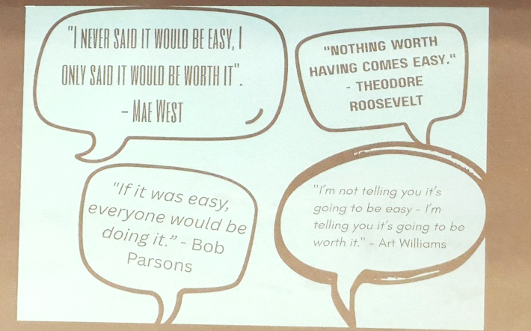
So May West once said I never said it be easy. I only said it would be worth it. " Teddy Roosevelt said, "Nothing worth having comes easy." Bob Parsons also said, "If it was easy, everyone will be doing it." And Art Williams said, "I'm not telling you it's going to be easy. I'm telling you it's going to be worth it."

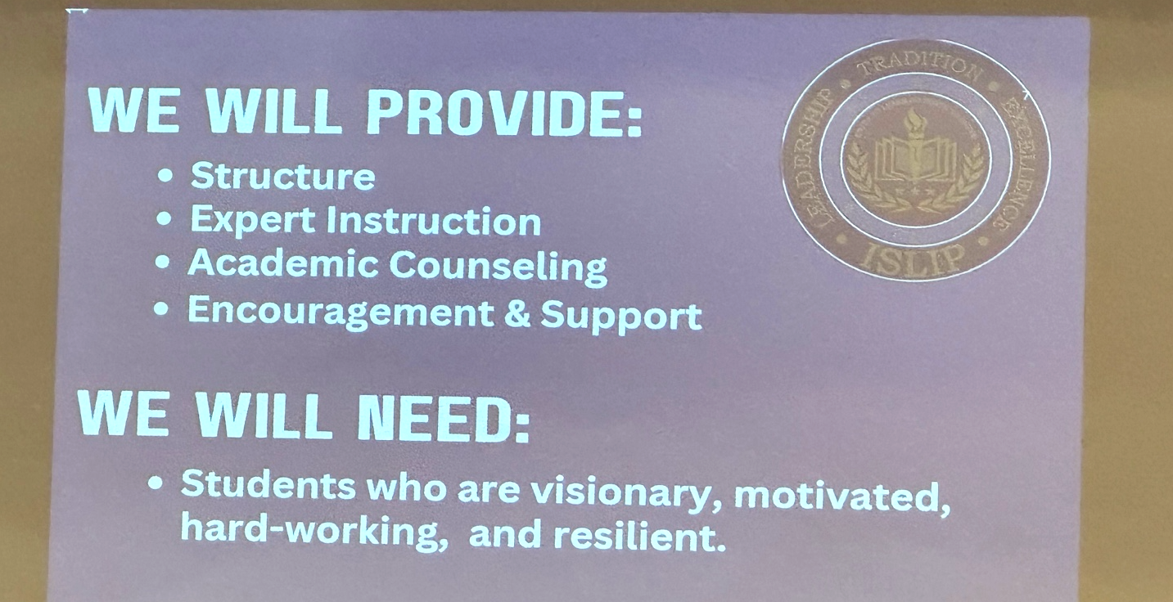

So, just for some points of emphasis here, this is, this is what we think we can provide for our students and families. A structure, expert instruction — whether that instruction come from our own faculty members or the faculty members on campus who are also outstanding — we can provide expert instruction. Dr. Bonahue can assure that on his end, and I can assure that on my end.

Um, our teachers that are here, we've been working with the college to get our teachers credentialed. So, that means we've sent, um, transcripts and resumes, whatever that may involve. So, we have a, a whole host of teachers that have been credentialed and approved by the college and we also have, um, I don't know how many faculty members at Suffolk County Community College that would be happy to have our students in their classrooms. Uh, so we expect more students on campus as a result of this.

We'll provide academic counseling both with our counselors and in conjunction with people at the college so that we can continue to work together on this. And of course we're going to give you all the encouragement, support that you need. Going as far as to say that, um, if we have to take public transportation to the campus for the summer courses, I'll be on the bus with your guys and girls, and we'll get them there. Make sure we do a good class, and we'll ride the bus back together.

What we need are students who are visionary, motivated, hardworking and resilient. Again, this is not for the faint of heart. This is not for somebody who just wants to go through the motions. This is for serious people who see this as a great opportunity. And we need families who want to partner with us and provide, uh, the necessary support. Okay.

So, um, we'll try to answer your questions because, uh, not every detail of this partnership is hammered out yet. There are things to be determined. There will be hurdles along the way. Uh, it will be some bumps in the road that we didn't anticipate, but, uh, we will figure it out and we will be with your children every step of the way if they decide to take this on.

And, uh, with that, if you have a question, maybe please go to the mic. Okay. Press the mute button. Hold it down.

- AUDIENCE MEMBER 1 >> Can you hear me now? Okay, here we are. First of all, thank you so much for bringing this conversation to the community. I appreciate it. I was wondering, you were talking a little bit about funding and I was wondering, um, for those students who would go on to college and seek out like financial aid, how would that work for the students of Islip? Is there an opportunity to apply for financial aid?
O’HARA >> You mean after this program? Is that it?
AUDIENCE MEMBER 1 >> You, you put up, um, some costs associated with each semester?
O’HARA >> Yeah. Um, I'm not sure if there's direct financial aid through the traditional format during the high school years and I don't think it would have negative impact, uh, because they are full-time students. So, um, uh, parents might have to find a money to pay $225 per course, etc. Part of the beauty of it is if it were the cost, it would cost you, they don't, you don't have to have it all at once, right? Pay it as you go, which makes it more manageable. Um, and then the people in this school district are so generous that, often times through some backchannels and quietly, we find people who offer scholarships and assistance, certain opportunities.
AUDIENCE MEMBER 1 >> Thank you.
O’HARA >> You're welcome.
- AUDIENCE MEMBER 2 >> This is actually a question for Dr. Bonahue. Um, so throughout the presentation there is a conversation about the Beacon program and accelerated, uh, college courses. Can you just explain to me the difference between the two?
BONAHUE >> I'll do my best. So the Beacon program as Dennis has described it is when high school faculty are teaching college curricula here in the high school. Okay. We also have high school students who can come to the college and take Early College, what we call Early College, courses. Students are still in high school. They have not matriculated into a degree program, but we can provide to qualified students access to many college courses if they'll come to campus. Those are the two flavors.
AUDIENCE MEMBER 2 >> Thank you.
BONAHUE >> You're welcome.
- AUDIENCE MEMBER 3 >> Hi, I have a few questions. I don't think everyone's lining up, so I'll just ask them. Um, how many kids are needed in a cohort to make this happen?
O’HARA >> Um, well, the, the Beacon courses that are in college, uh, you know we have I don't think that'll be an issue. We can't, we can't run a course in high school for two students because we just can't afford it. But our college courses are not, excuse me, not undersubscribed. So I don't think it'll be an issue. Um, I'm not sure about the college. They can't run a class either with two students. So we need a number of people to join on board. Unless of course, um, our students might go to campus and join a course that's already scheduled and has room in it. So I can't directly answer your questions. We're going to do everything we can to make it work.
BONAHUE >> If I could suggest there are ways in which this might work as a cohort program. There are ways in which it may work as an open enrollment program. That is to say, for a student who wants to come to the college to take part in classes, they may be able to do that on their own. Now, if there's a large number of students and the high school can support a cohort, we would love to we would love to have that, but it could work either way.
AUDIENCE MEMBER 3 >> So, it's not ironed out because I'm understanding we're a pilot, right? So, we're, we're at the guinea pigs. So my question is it's not ironed out that if you have a group of students who have all different pathways in mind, what if those students aren't enough to fill these classes now that cohort now that pathway is kind of at a dead end? Unless they have the ability to branch off and go to the college or go somewhere else.
O’HARA >> Yeah. So, um, so you're partly correct. Um, although I don't, I don't think it'll, that'll, I don't think that'll be one of our bigger hurdles to clear because the college has courses. They have a number, x number of sections of sociology for example. So if we have five students that want to jump on board this summer, we're going to ask them, "do you have a section of sociology?" and I'm going to take them to campus and we're going to get them in. If we have 30 students that get on board this summer, I'm gonna call the college and say, "Can you give us a professor because I have 30 students?" And so, we're going to solve it. I, I can't predict that because I don't know what, what the engagement is.
AUDIENCE MEMBER 3 >> How many Beacon teachers do we have here in Islip?
O’HARA >> Oh my gosh. I don't know off the top of my head. Do you have any idea? Somewhere between 15 and 20.
AUDIENCE MEMBER 3 >> Now, if we're looking at we have current partnerships with other with other colleges like SUNY Farmingdale and I noticed that with this partnership, Suffolk would be taking a lot of those partnerships. It would be kind of not having some of them. What about those students that are currently a part of those programs?
O’HARA >> It doesn't impact them. We didn't, we didn't eliminate the courses. We just found, uh, we worked together to identify Suffolk County Community College's equivalent and so the course that was there last year will be available next year. It just will be offered through Suffolk County Community College instead of instead of Farmingdale State.
AUDIENCE MEMBER 3 >> But what about those students that have intentions of going to Farmingdale like that, that, they join that for those reasons?
O’HARA >> Well, they could still go to Farmingdale. It's not a problem.
AUDIENCE MEMBER 3 >> Now, if you could go back to timeline for me, the one with the prices on it. Now, which of these classes? Just because it's the most comprehensive, you know, same.
O’HARA >> Oh, wait. Sorry. Sorry, this one.
AUDIENCE MEMBER 3 >> So I just, because I don't have a high schooler yet, and I don't know the course catalog. What, which of these are here on Islip’s campus and which of these have to be taken at Suffolk?
O’HARA >> Okay. So in this example, this possibility…
AUDIENCE MEMBER 3 >> …right because hypothetical…
O’HARA >> …it will vary by student. The courses that are at the bottom that are identified as summer session are on campus, and the classes that are at the top that are identified as freshman year, sophomore year, junior, senior year, are in our building.
AUDIENCE MEMBER 3 >> Okay. And those are during the school day?
O’HARA >> Correct.
AUDIENCE MEMBER 3 >> And that's not, now, those summer session classes are obviously classes offered during the day in the summer, four days a week, that kind of a deal, for the…?
O’HARA >> Or, or virtually
AUDIENCE MEMBER 3 >> Okay, or virtually.
O’HARA >> And, and, look, you said it best. We're, we're piloting this. We're, we're trying. And so, um, what I think is best is for us to have opportunities to have students take courses virtually because they could experience that in college. I think it's best for them to have some experiences with them on campus because hopefully they're on campus after. And I think it's likely that the majority of people that take advantage of this will earn a year and maybe be on the campus for a year. And I think it's terrific if I go with them for a couple of class days here or there over the summer. And then when they end up there on their own, they're very comfortable and very familiar with the campus. So we think this could happen in multiple ways.
AUDIENCE MEMBER 3 >> I just, I, I believe in education. I was an educator. I understand the importance of college. And I also believe wholeheartedly that college is not for everybody. And I know while we stand here and we talk about this, I just want to remind people that an electrician gets anywhere from $125 to $250 to walk in the door. An HVAC person gets $150, if not double that if it's an emergency. These are also things we want to keep talking to our students about. We have all these college tours and all of this stuff going on, but I think we're forgetting those programs as well. And none of these will partner those kids towards those programs.
O’HARA >> I'm just going to push back a bit because, um, two points or three points maybe. First of all, this is optional, right?
AUDIENCE MEMBER 3 >> Right, I know it is but…
O’HARA >> Well, just let me finish please. Um, so if a, if a family and a student want to go this path, we're trying to create something that will save them all. Um, secondly, um, Dr. Bonahue emphasized the programs HVAC, uh, auto, auto repair, etc. We're trying to help our students be able to access those programs. So, so my hope is that we have this partnership and they do some classes while they're with us and then they seamlessly go into the HVAC or the auto repair whatever other programs you may have. So, that's part of our thinking. And then I guess the third point is we're not reducing any BOCES opportunities. So, we, we have those programs still available to our students.
AUDIENCE MEMBER 3 >> So, how does it work that these classes help a student get into like the HVAC program and something like that? Aren’t some of these courses prerequisites to be, you need AP business or AP business or AP bio to go to the HVAC or the automobile program…?
BONAHUE >> For something like HVAC or automotive, to my recollection, I don't think there's any prerequisites for these programs. Uh, it could help when a student is involved, interested for example in the health sciences, if a student has had during their high school years for example, um, say they've come to the college to take a course like medical terminology or something like that, then they already have that under their belt and that's one less prerequisite they have to do when they come to the college.
AUDIENCE MEMBER 3 >> Right, no, no that makes sense to me for the health sciences, I'm talking more of the, the trades but that's fine, um, I think I think those are all of my, my questions…
O’HARA >> One more piece too, um, you know we, I started the presentation with the data about you know what the quality of life may be like if you continue your education. So even if a student wants to do a year's worth of credit here and go straight into HVAC, that's fine, too. But they're better off, I think, with the education personally. Fair enough.

- AUDIENCE MEMBER 4 >> Hi, how are you? Um, so two things. Number one, I'm impressed. Um, as a person who sat on this board, um, worked 12 years to improve program in this district and watching where you've come now. This is an excellent opportunity. I've had the opportunity seeing nationally Early College high school programs across the country in different states. Some states have a centralized education system, and this is offered through their, uh, regular articulations between college and high school.
Um, for Mrs. Moon, the programming that's up here is a liberal arts programming which is the base two years that you would get in any college, whether you take those two years over the four or the early two. So it really, um, these programs are, are more establishing you ready to get into your career trajectory once you are in that four-year program. The last thing I'll say is, um, I'm a BOCES board trustee and I, I work with my colleagues here. Um, there is not an “or.” Students who go to BOCES and do HVAC, electrician, plumbing… um, our nursing students come out with an LPN, um, ready to get an LPN. They can't get an RN because that's a four-year degree. So our students get ready in the base programs and base certifications and then move on to following education, even our students in HAC. I will tell you that in this room, there is a student who was a BOCES student who is an educator in this district. So this is not an “or,” it's an “and”—and opportunity is economical. So I applaud you all. Um, I will tell you that the arrangement with BOCES is that BOCES has a certain number of seats that are allocated to Islip schools. Islip schools chooses how they use them and that is a smooth three-year, three-year cost average. So they're being economical, BOCES is economical. Kids have choices and it shouldn't be one or another. It can be both.

- AUDIENCE MEMBER 5 >> Hi. Um, I have a question about, so I guess like the logistics of the scheduling? if it's a path, some of these classes are happening in school. I'm really looking at sophomore year, like I see those core classes but then there's not a math up there? And there's not a global 2? Like how does all that fit?
O’HARA >> Yeah. So, um, so that we have a nine-period day, right? So, students will have to be very eager and they might have to decide, “Hey, everyone, I want to go for this, so I'm going to fill all nine periods.” Or they may have to say, “Um, you know what, Dr. O’Hara, you proposed four credits, uh, you know, in the summer between sophomore and junior year, but I'm going to take seven.” Uh, or “Dr. O’Hara, you, you listed only summer session two, um, but the colleges have a winter session which is, uh, four or five weeks in January. The colleges have a summer session one.” And I hope that, I hope that I have a handful that come and say, “Dr. O’Hara, can you help me get a virtual class in January? I'm, I'm cooking with gas and I want to keep going.” So, it's, it, this is a sample and a possibility. This is not a how you do it. This is a “we showed how it could work,” and then it'll be very individual….
AUDIENCE MEMBER 5 >> It’s flexible.
O’HARA >> …you know, did you say it's flexible? Yeah. That's a good starting word but quite honestly, I don't even think flexible is the right word. It, it's really going to be per -, yeah, somebody just said personal, I think. Oh, thank you, Kathy. Um, yeah, it's going to be individualized. Thank you, Mr. Dean. And it's going to be like “What, what am I capable of?”
Listen, you know, I'm standing in front of you today. I'm a superintendent. I got a doctorate. But when I was in high school, I was not capable of multiple AP courses. I, I've evolved, uh, but some students… I can tell you in the class of 2026, 70% of our students in this current graduating class, 70% have taken one AP exam. I can tell you that 21 students have taken 10 or more. So, and I can tell you that 87 of them have taken four or more. So, if you're a student who's taken four AP courses, that's off the mark of, of the 10, but maybe you can stretch and take six, and then we can find other college credits along those different interessions and so on.
So, when I stand in front of you this evening, I can't tell you how it would work for your child. Um, and I know that's not what you're asking me, but it's going to be very dependent. That's, that's why I kept saying over and over again, your future depends on a lot of things, but mostly you. It, it will depend on, on how our students want to grab this bull by the horns and, and how determined they are and how motivated. It'll depend on a lot of things, but that's a big part of it.
AUDIENCE MEMBER 5 >> And then my other question is some of these courses, right, like the bio class that's offered now. So, if students are doing the Beacon program, would they be potentially in classes with kids that are not doing the Beacon program? or these are exclusive classes?
O’HARA >> Oh, that's such a great question. So, um, in, in some we have, we have, I think I'm going to say three possibilities here. Um, one of them is you're in a straight AP course. One of them is you're in a Beacon course. And in some cases, through our partnership with the, our guests that are here tonight, we have some situations next year — actually we have one case this year — and we'll have more next year where, um, students are doing both AP and Beacon at the same time.
So here's what that means. Right now we have 91 students, and I always get mixed up… I think it's AP language and literature, thank you, AP language, we have 91 students across four sections. 35 of them are also paying for the credit for the Beacon program. So, um, some of them might earn the three or above and be able to earn, get college credit and some of them may get the college credit through enrolling in and getting the necessary grade and get the credits through Beacon. So, we, we have we will have those three possibilities.
AUDIENCE MEMBER 5 >> So, the dual enrollment courses that exist already are already Beacon courses? They’re just not this whole program with the summers and the winters…?
O’HARA >> That's another great question. So, yeah, so, we all those classes that were at the bottom, the first three columns in particular, they're already Beacon, right? So they're here and our students have been availing themselves of those courses for quite a number of years. What's different is nobody's ever taken the time to map this out and say what's possible and we're trying to help the students. I, I'm, listen, I reached out to Dr. Bonahue, to make this presentation a couple months or so ago, and I said, "I want to enroll. I'm ready to go back to college." And so, I'm going to get on a bus and go to college with these guys. If I have to, I'm enrolling in sociology to make it work for our students. And we're, we're all in and we're going to figure out how to make it work. The only thing that's different on that list you saw before is all those, the first three columns that are now Suffolk County Community College, they weren't all Suffolk Community College this year. So, we've worked with the college. We, we, we gave, um, Miss Calla all the courses we offer here that are dual enrollment through other colleges. We said, we want, Suffolk’s mission is to be the school of choice for Suffolk County students. So we, I, felt, you're our choice. We want to get in this relationship together. And so which of these other college courses can become, you know, do you have on your campus? And so we did that work to make it easier, like, I don't the word's not easier but more streamlined, you know, like, to make it work.
AUDIENCE MEMBER 5 >> Thank you, that was helpful.
O’HARA >> You're welcome.

- AUDIENCE MEMBER 6 >> Hello. Um, I came here for information. So, thank you to everyone that has provided the information. Um, I've had three girls go through the district. I have one remaining who's in 10th grade. Uh, all of them have had wonderful educations here. They have taken advantage of what has been offered for schools. Um, I'm curious. I can't figure out the missing piece. So, my daughter's in 10th grade. You're calling this a pilot program, but all the AP courses have been offered. The Beacon program has been offered. The Farmingdale State College program has been offered. So, what piece is missing for this associate’s?
O’HARA >> What's new?
AUDIENCE MEMBER 6 >> Is it the summer sessions?
O’HARA >> Yeah, we've never had Early College here to my knowledge. So, that's new. And, and, also, um, uh, the college has made some very rare exceptions regarding letting the students try Early College class and so that part might be…
AUDIENCE MEMBER 6 >> If she's on a trajectory, she's in her sophomore year, junior and senior year, I anticipate her continuing with the AP courses, so it would be the summer sessions? Three, I assume?
O’HARA >> Right, you said sophomore, uh, so she would have two opportunities for summer sessions, and also if this is viable for her and, and then depending on what kind of student she is and her desire to try to move this along, uh, she could try, um, uh, the way that I propose this is summer session two, which is July, you can see the dates, July 12th through August 18th, but summer session one begins late May or something like that and goes into late June. I forget the exact date, but you know, we could, we could try that too. Um, and that would give more opportunity for credits. I only propose summer session two for starters because I'm trying to get a first cohort to come with me, take the classes, get the ball rolling, and then as we find out, students are more motivated and some may be more capable than others. They might be able to handle their full high school load and for May and June taking a course in the evening. Not everybody can, but some may be more resourceful.
AUDIENCE MEMBER 6 >> The cohort can be a variety of different ages from 8th through…?
O’HARA >> Yeah. Well, so, for example, I'm calling the 9th graders the first cohort because like they're the first people to start after grade 9 and between grade 10, but in that first cohort could be some current 10th graders, even current 11th graders.
AUDIENCE MEMBER 6 >> All right. Thanks for the information.
O’HARA >> Yeah, my pleasure.
- AUDIENCE MEMBER 7 >> I have some questions. So, they had to get a three in every single AP class and so they don't have to take the class again or something like that.
O’HARA >> Well, no, they don't. They, well, okay, so, good question for the, um, yeah, it just they don't have to take the course again, but it just won't, it, they can't use it for college credit. They have to earn that score.
AUDIENCE MEMBER 7 >> And say they don't finish, say 40 credits, they don't have to see it out to the end.
O’HARA >> No, you, I mean, if you have 40 credits, then we call up the college. We say, "Hey, we have a fantastic student who's earned 40 credits and we want to get on your campus for two semesters and be done."
AUDIENCE MEMBER 7 >> Thank you.
O’HARA >> Yeah, my pleasure. Any others?
- AUDIENCE MEMBER 8 >> One more question. Um, can a student who takes an AP class and evening classes who decides not to enroll in this program to earn an associate’s degree still take advantage of classes in summer at Suffolk?
O’HARA >> Yes.
AUDIENCE MEMBER 8 >> And are they limited in terms of what so they could take at Suffolk?
BONAHUE >> The answer would, the answer would be, somewhat and it depends.
AUDIENCE MEMBER 8 >> Okay. I'm just wondering like my daughter is currently a sophomore. If she didn't necessarily want to take that course load junior year, but still wanted to take classes at Suffolk, she could?
O’HARA >> I'm going to say generally, yes. Our contract with the, the school as it currently, as it currently stands, I believe has provision for qualified students to come, and to come, as they're recommended by the school district, to come and take courses at Suffolk. Now, it doesn't mean they can jump ahead in math, right? It doesn't mean they can jump into a nursing course, but if they're interested in the liberal arts courses that, that Dr. O’Hara laid out, then we review those cases on a case-by-case basis and try to serve that student.
AUDIENCE MEMBER 8 >> Okay.
- AUDIENCE MEMBER 9 >> Hi, I have a question. I'm just curious how, you know, you're selling it to the parents here. It's a great opportunity. I'm just curious how you're presenting this to the students themselves and how you get them to buy in — especially at such a young age of, you know, the 8th grade and 9th graders when they're in, the mindset isn't quite there yet because once they start putting these grades on a college transcript, that sticks.
O’HARA >> Yeah. Uh, that's a, thank you for that question. So, um, with the, uh, regarding the 8th graders, we, this is, I forget if it's our third year already with these two AP classes in grade 9. We've had good results. Um, I don't remember how many sections of, of each, we, we've had, but, um, the answer to your question is a couple of ways.
Number one is, um, the middle school counselors have come to see this presentation in advance of tonight. Um, they already advise students in terms of course selection and, um, uh, Ms. Stern, the middle school principal, and the counselors, uh, are considering a town hall meeting to kind of explain some of these opportunities to the 8th graders and get them to understand what the opportunity is and also what the commitment is.
And so we, um, I'm going to make up an example where we have let's say 200 students in 8th grade. Could be a little more, could be a little less, but, um, and let's say that we have, uh, two sections of bio APES. I don't think we're going to have 10 of them. Maybe, maybe this will turn into three. Uh, I, I, I think when you do things like this, there's more people out there that are capable than they know they are. And so we present them with the opportunity, the encouragement, the support, and then, um, uh, they surprise themselves.
And I I can tell you that, um, today, just today, I was looking at AP data that goes back to 2022, looking where we've been between, between then and now, and, um, uh, I want to say that in 2022 we had 98 students take at least one AP exam when they, uh, by the time they graduated high school. And the passing rate among all those students was 81%. And a couple years ago we did some things to encourage more students to take AP exams. And, um, so that was 98 students. And this year's graduating class we have 155 students that have taken at least one AP exam. And while I don't know their passing rates yet because they're not done, they still have to take those exams, I can tell you that last year's graduating class had a passing rate of 80%. And, and there was something like, and, and, uh, I forget if it was at 116 or 119? So, we had an uptick of 18 or 16 students and our passing rate didn't go down. So I think that's where the stretch comes in and that's where we give the support and we encourage more people capable.
AUDIENCE MEMBER 9 >> So just to, to, uh, confirm so it's basically a conversation with the counselor and the student, or is there any type of presentation like this that is being given to the student?
O’HARA >> For the 8th graders, yeah, Ms. Stern is nodding yes for me. So for the 8th graders, there'll be a presentation in a town hall format. And then for the high schoolers, you know, they already know about college selection and, and their couns, our counselors are on top of what this is. And for them, we're kind of, um, we're trying to give it more structure, organize it. A lot of the course selection process won't change much here except for if they say, "Whoa, like I had an epiphany. I realized I have this many credits and if I make these course selections, I could do even a little more for myself."
AUDIENCE MEMBER 9 >> Thank you.
O’HARA >> You're welcome.
- AUDIENCE MEMBER 10 >> Hello. Um, I just wanted to say I thought Ms. Moon's question was wonderful actually and it really spoke to me. Um, especially as someone who's been on the BOCES board for 10 years. Um, I spoke with Dr. O'Hara at length the other day about this. So I was hoping you could just answer a question maybe for anyone who was interested. Um, my own son is in special education going to BOCES next year in 11th grade and we had just assumed he would go to BOCES and that would be that would be kind of his track and what he wanted to do. Um, in speaking with you about my, the same questions that Ms. Moon brought up, you had, um, gone through actually, you took time with me to look through the Suffolk programs, and found that the programs going to BOCES for they actually offer at Suffolk a variation of that, that type.
O’HARA >> Dr. Bonahue, you folks have that type thing? Yeah, they do.
AUDIENCE MEMBER 10 >> Yes. We had talked about how, um, maybe he could take one or two classes and try it. And so to kind of echo what Ms. Romano said, I after speaking with you, I do feel like it offers it definitely gives you opportunities that we've never considered before. Um, but just from the special ed lens, could you just speak to like 504 accommodations or someone with an IEP or 504 accommodations and how that would work with these classes?
BONAHUE >> So, again, I'm not an expert on 504s and IEPs, right? Especially for the secondary level. Um, what we do have at Suffolk is, um, right, we're given eligibility requirements, right? The state, state ed lays out that we partnered with high school on those eligibilities for participation requirements. Um, you mentioned vet tech and I just want to emphasize, um, the map that, that Dennis presented is, is a map into the general liberal arts program. So it's, it's, it does not represent an opportunity, for instance, to get started with vet tech while a student is staying at the school.
O’HARA >> Could it, could it, there is an English class. If they took that, they could apply to the program?
BONAHUE >> If a student took English or any other kind of liberal arts course, they could apply to any program.
AUDIENCE MEMBER 10 >> Yes. I think I think that was the point that, um, we could try a plan that we've weren't even considering before.
O’HARA >> Um, I, I believe so.
AUDIENCE MEMBER 10 >> Yeah. But I do want to say, um, Dr. O’Hara spent so much time with me the other day answering questions. So if anybody has questions, I'm just going to put it out there, he gives out his phone number all the time.
O’HARA >> It's true. I've never been pranked, so don't start. Good evening.
- AUDIENCE MEMBER 11 >> Good evening. So my question is, um, regarding the rising juniors. Given the limited amount of time that there is for this possibility for them. What kind of advisement is going to take place over the next couple of months?
O’HARA >> Yeah, thank you for that really good question. So, what our counselors are working on is almost making, um, you know, they have a, I'll just call it a checklist for lack of a better word, but, um, they have a checklist that says, you know, you have to take four years of English. We're in high school, you're a rising junior, so you have two years done, so we need to take a year of English, right?
And, um, they're in the process of creating a similar document that we have the college requirements on it. And so, the advisement will happen between the student and the counselor. As parents, you should call the counselor, ask maybe to join the meeting or ask these questions. And, and what I recommend you do is ask your child's counselor to, to can you point out to me, my, my child's AP courses and any college courses she, uh, or dual enrollment she may have already taken, how close are we? That's why in that one slide I put “join us in the summer” and then really do an assessment of your transcript and see how you know what you may have. And you might find that you have a semester and you can be at Suffolk County Community College for three more semesters. You may find that if you really work hard and, and, and stick to it, that you can somehow between now and then get the second semester and have to be on campus for one year. Thank you for that question.
Well, I thank you for your time. Mr. Dineen, is, uh, did you want to say anything?
ISLIP BOE PRESIDENT PHILIP DINEEN >> No, I just wanted to say thank here. Again, we all want to see students succeed. It's just another opportunity. It's another pathway and really curious to see, you know, how students embrace this and participate with this. So, thank you.
O’HARA >> We're going to move to our budget presentation, but if it's okay with you, we'll take a five-minute break.

