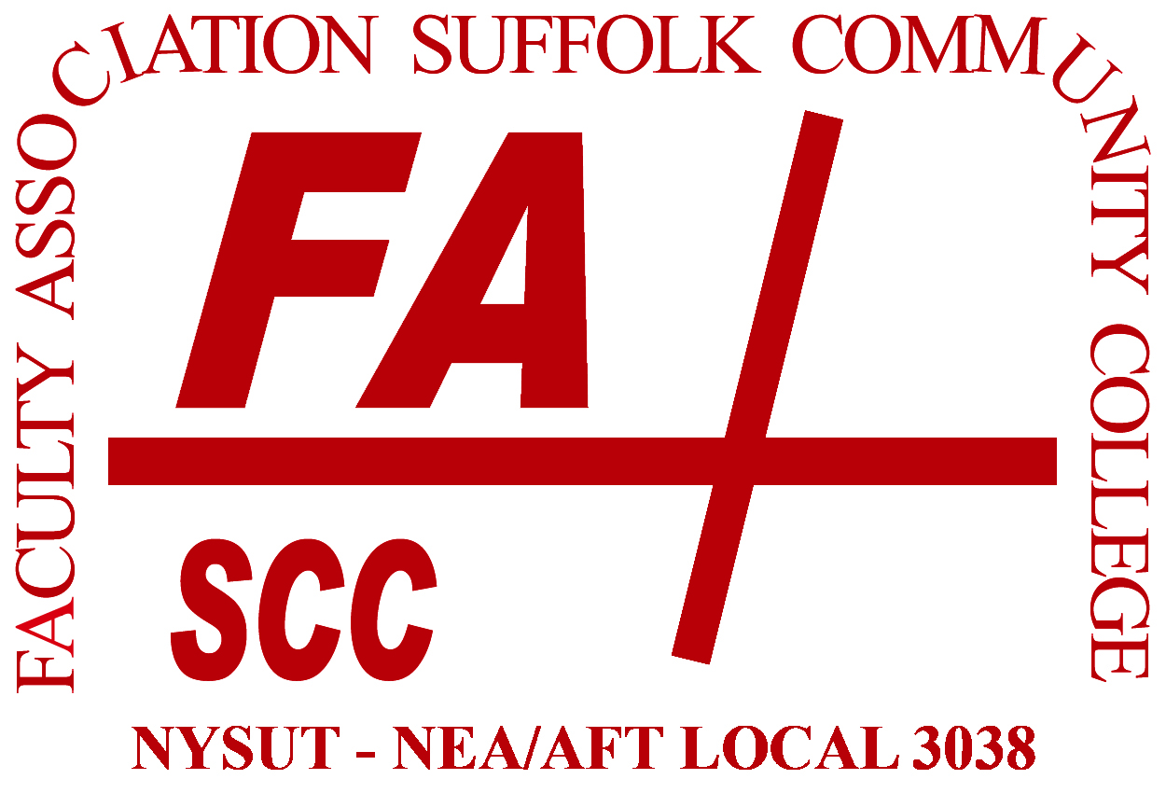 | FA Executive Council Representative  2022 Nominations Form
Dear FA member:

Seventeen Executive Council (EC) positions are up for election this spring, which includes one vacancy. You are receiving this nomination form because you are in one of these 17 constituencies.

- The EC is the policy making body of the FA. Duties of the council and its elected representatives are on pages 11-12 of our Constitution and Bylaws (Article II Sections B and C).
- You may only nominate EC reps in your own area; outside nominations will be disregarded.
- As noted in the FA Elections Procedures, nominees must be members in good standing.
- Type your nominations using the form below and return to the FA office. Nominations must be received no later than March 2 at 12 noon.
  - By email: cynthia@fascc.org
  - By post office: Southampton 224J
Suffolk County Community College
533 College Road, Selden, NY 11784

- The election timeline is as follows:

  - February 1 Call for nominations
  - March 2 Close of nominations
  - March 18 Nomination accept/decline due
  - April 11 Ballots mailed to home addresses via US Postal Service in contested elections
  - May 6 Close of voting at 12 noon; ballot counting at 12:30 pm
  - May 12 EC certification of election results

College-wide Adjunct Executive Council Representatives
- Business, Accounting, Communications, Telecom
- Nursing, Phys Ed, Health Sciences
- Foreign Languages, ESL, ASL, Reading
- Social Sciences
- PAs & Specialists – Instructional Labs
- PAs & Specialists – Skills Centers
- Guild, Retiree, PAs & Specialists – Programmatic

Full-time Representatives: Ammerman

- Accounting, Business Admin., Business Information Systems, Legal Studies
- Music, Visual Arts, Theatre, Philosophy, Women’s Studies
- Nursing, Health and Human Services, Phys Ed
- Engineering, Computer Science, Industrial Technology
- Biology and Physical Sciences
- English
Full-time Representatives: Eastern
- Library, Humanities, Counseling

Full-time Representatives: Grant
- Nursing, Health Science, Phys Ed, Veterinary Science
- Library, Counseling, Media
- Humanities

College-wide Constituent-based PA & Specialist Representatives

- Technical Areas, Instructional Centers

If printing, sign and return to Cynthia Eaton at  the FA office: 224J Southampton (Ammerman).  If submitting via email, send from your FA or  SCCC account to cynthia@fascc.org. | _________________________________________

