Send an email from Blackboard
- Blackboard lets you quickly and easily send emails to one or more classmates and to your professor without needing their addresses. To read emails, you need to continue accessing your email in MySCCC.
- This is a great way to email your professor because Blackboard automatically attaches your course number and section (such as ENG102-300) to the email.

- In your class website, click Email in the course menu at left.
- Click Single / Select Users.
- You’ll see a screen that provides the names of everyone in the course—including your professor—in the panel on the left.
- Highlight the name(s) of the individuals you wish to email in the left panel. Hold down the Shift key and click to select more than one name.
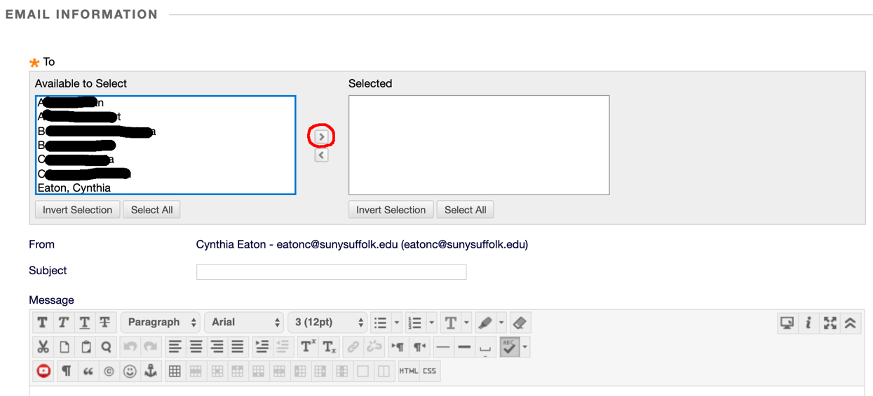
- Click the greater than symbol [ > ] in the center to move the selected name(s) to the right.
- Fill in the subject line and your message in the areas provided.
- If you wish to include an attachment, click the Attach a file link, then Choose File. Browse for the file you want attached, then click Open.
- Click Send.

