Post to a Discussion Forum

- If your professor has asked you to submit work to the Discussion board, here’s how.

- Log into your class website, then click the Discussion link in the course menu at left.
- Click the name of the discussion forum where you need to submit your work.
- In the forum, click Create Thread.

- Type your subject; this might be the title of your essay or other assignment.
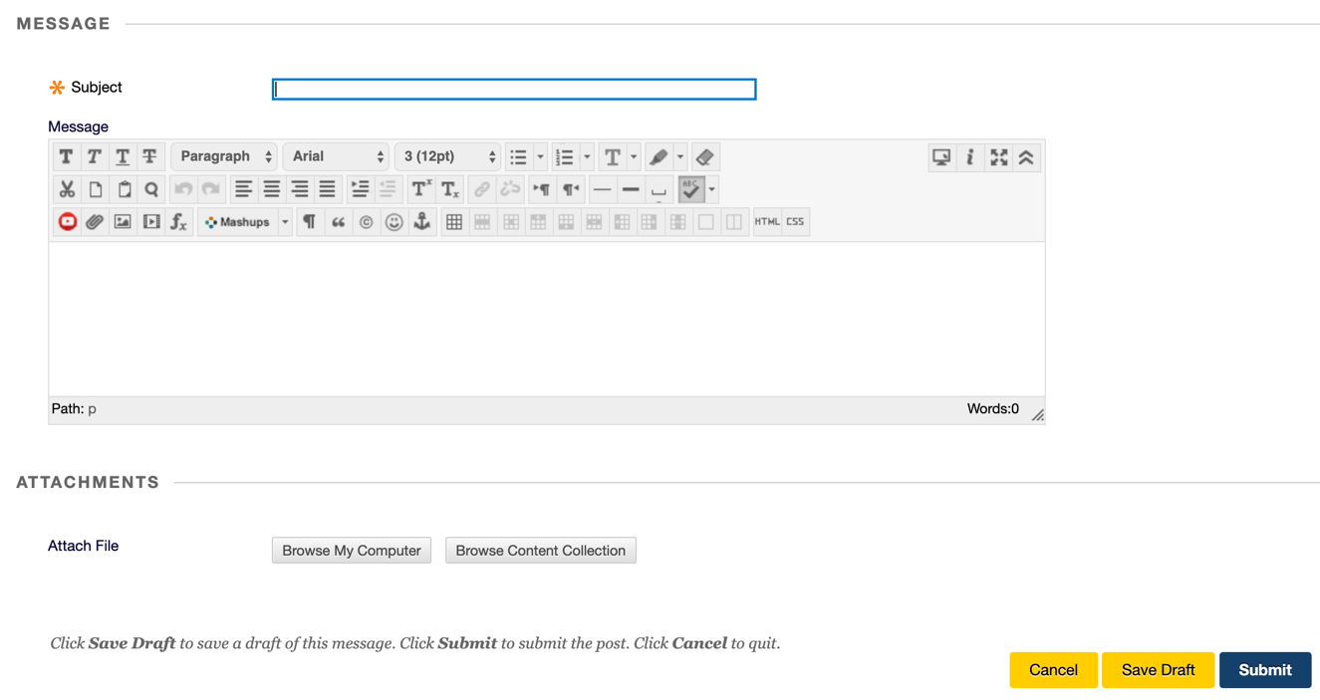
- Depending on your professor’s instructions, you might post your work right in the message box provided or attach it as a file. If putting your work in the message box, it’s a good idea to type and save it in your word processing program first (e.g., Word, Google Docs, Pages), then copy and paste it into the message box so you are sure you have a copy.

- If attaching a file, click Browse My Computer, locate your file, highlight it, and click Open.

- Click Submit. Then review the forum page to make sure your work actually posted. It will show your name, the subject line that you typed, and the date and time you posted it.

- If your professor asks that you reply to others’ threads, hover your cursor at the bottom of any thread and you’ll see a menu appear. Click Reply, then type your subject and message as described above, then click Submit.

HELPFUL HINTS
- On the main discussion page, the screen shows you how many posts total, how many you haven’t yet read (how many are new), and how many replies to you have been posted. This helps you avoid having to click into each and every forum to check for new threads and replies.
- It can get tedious to click into each thread to read them one at a time. You can collect all of the postings into a single screen, which makes it easier to read—or to print—all at once. To do this:
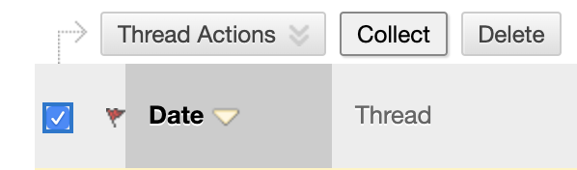
  - Click into the forum you wish to view.
  - At the top left of the forum, just to the left of the small red flag, click the check box to select all threads at once.
  - Click the Collect button.
This collects every thread in that forum into a single screen, so you can print it or scroll down through all of the postings at once.

