Submit Work in Assignments

- If your professor has asked you to submit work to the Assignments area, here’s how.

- Click the Assignment link in the course menu at left.
- Click the name of the assignment that you need to submit.
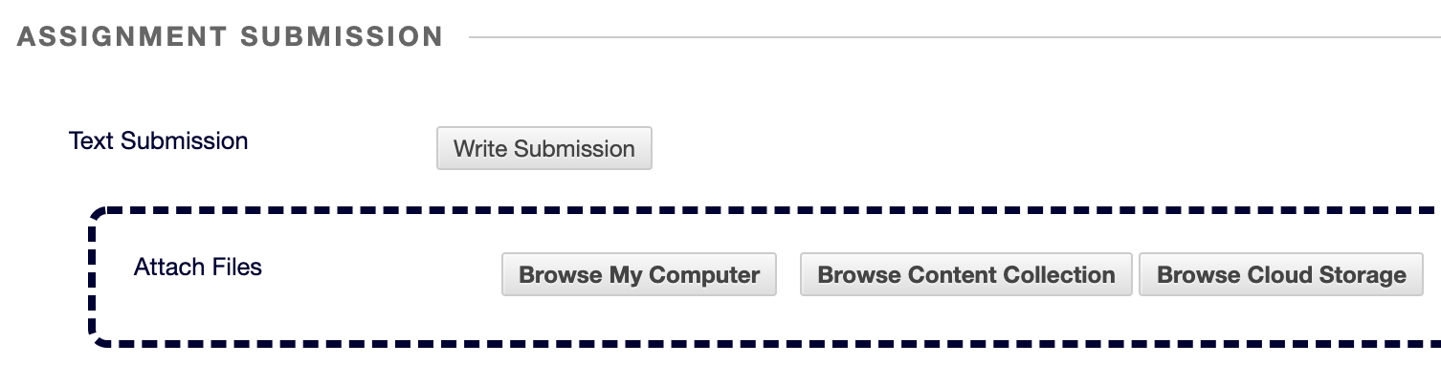
- There are two ways to submit to assignments: Write Submission or Attach Files:
- If your professor wants you to use Write Submission, click Write Submission, then type or—better yet—copy and paste your work from your word processing program (e.g., Word, Google Docs, Pages) into the text box provided. It’s best to type and save a copy of your work so you always have a copy. (The comments area at the bottom is in case you want to say something extra to your professor about your assignment.)
- If your professor wants you to attach a file, click Browse My Computer, locate and highlight your file, then click Open. (The comments area at the bottom is in case you want to say something extra to your professor about your assignment.)
- Click Submit.

HELPFUL HINT:
- If your professor has enabled students to have multiple attempts to submit an assignment, select the assignment link again, and you’ll see a Start New button on the right side of the Review Submission History page. Click Start New to re-submit.

