Access Your Class in Blackboard
- Go to https://www.sunysuffolk.edu/.

- Click MySCCC and log in with your college username and password.
- Click the Suffolk Online tab.

- Click the Blackboard icon and then on the next screen click the Blackboard login icon. This will take you to SCCC’s Blackboard landing page.

- You may also go to the direct web address—https://suffolkonline.open.suny.edu/—and bookmark it for quick access.
- From the Blackboard landing page, click the Courses tab at the top right.
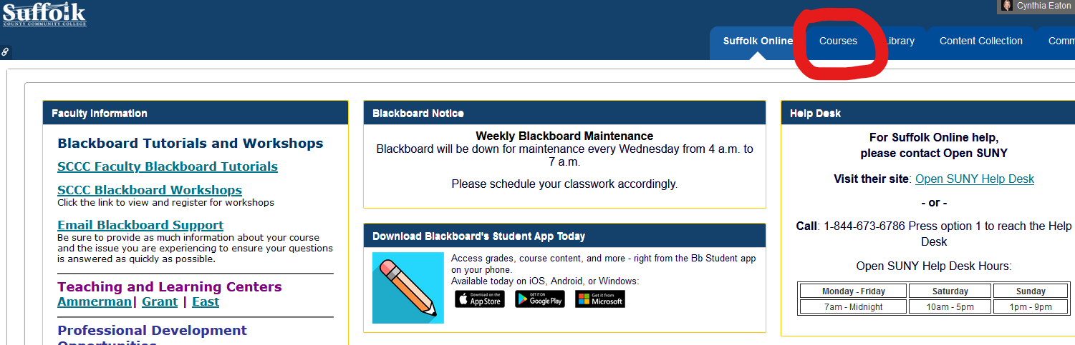
- From the Course List at the right side of the screen, click the link for the course you wish to access.

HELPFUL HINTS
- It’s wise to organize your course list and have your current semester courses appear at the top. Here’s how:
- In the blue Course List bar, hover your cursor at the far right of that blue bar. You’ll see a small gear icon appear.
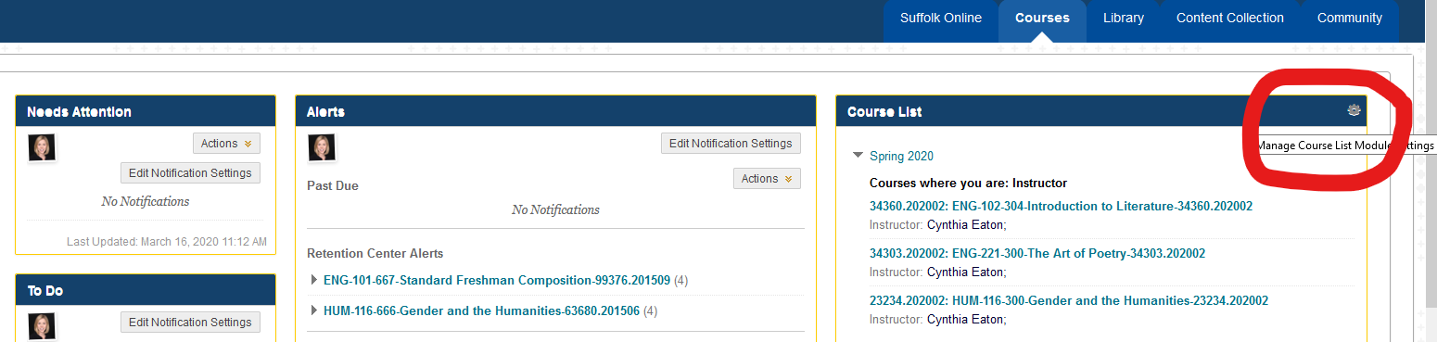
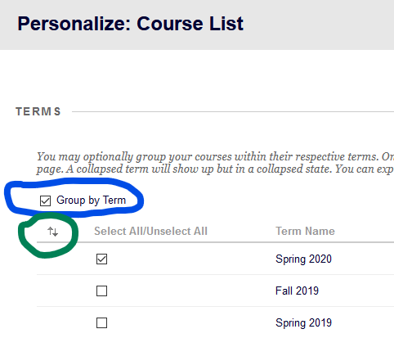
  - Click the gear icon to see the personalize course list screen.
  - Click Group by Term, then click the small set of up and down arrows immediately below that to see the Reorder box.
Find and highlight the current semester in the list, then click the small up arrow until you move it to the top of all semesters listed.
  - Click Submit, then Okay when it says “Items have
been reordered.”
  - Click Submit.

.

